|  |  |
| --- | --- |
| **External Document** |  |
| <Course Code>  <Couse Name> |
| [XXXX], [Odd / Even] Semester |

* Project Title

megAWealth

* Introduction

megAWealth is a real estate company that was founded in 2008. In this modern era, people are starting to search for real estate using the internet. Because megAWealth doesn’t want to be left behind and get beaten by their competitors, megAWealth decided to make a website to make it easier for people to buy or rent houses using their website.

Using the megAWealth website, people can search, buy, or rent real estate. It will make people who want to find real estate have a much easier time using the megAWealth website. They can look into real estate without having an account, but if they want to buy or rent the real estate, they need to make an account first. The admin for megAWealth can also manage the real estate directly in the website. With this website, megAWealth is hoping for more customers and easier time for the customer to look for real estate.

* Report / Documentation

1. GUEST
   1. Register

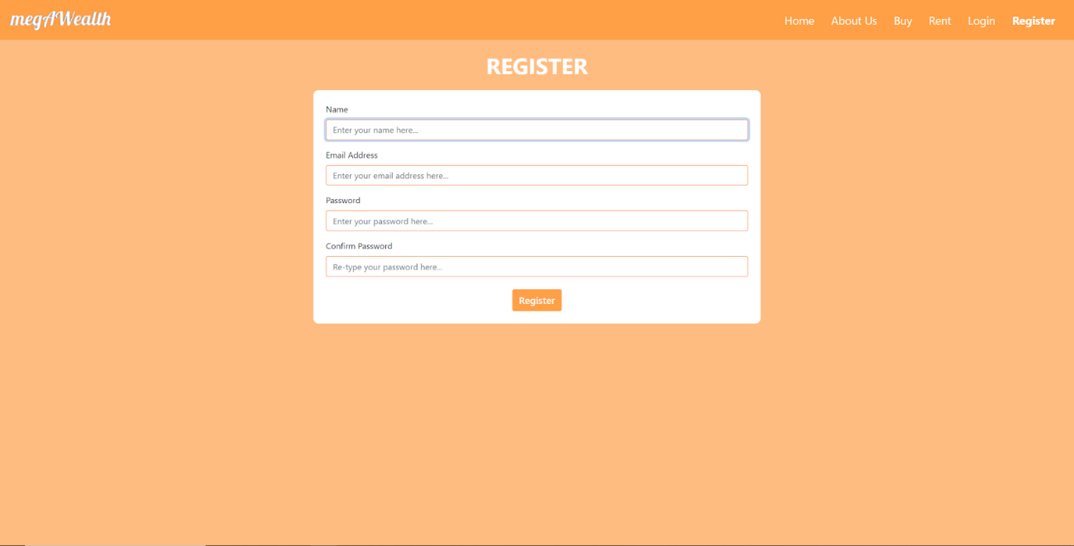

This page is where the guests can register themself to use all of the features of megAWealth. This page can be reached in the navbar on the top of the web app. The guests need to fill in their name, email address, password, and confirm their password. They must fill all of the field and pass the input validation. The email address must be a valid email and haven’t been taken before by the other user, the password must be at least 8 characters long, and then the password confirmation must be the same with the password written before. If the guests don't pass the validation, they will be redirected back to the register page with some error messages to fill again the problematic field as shown below.

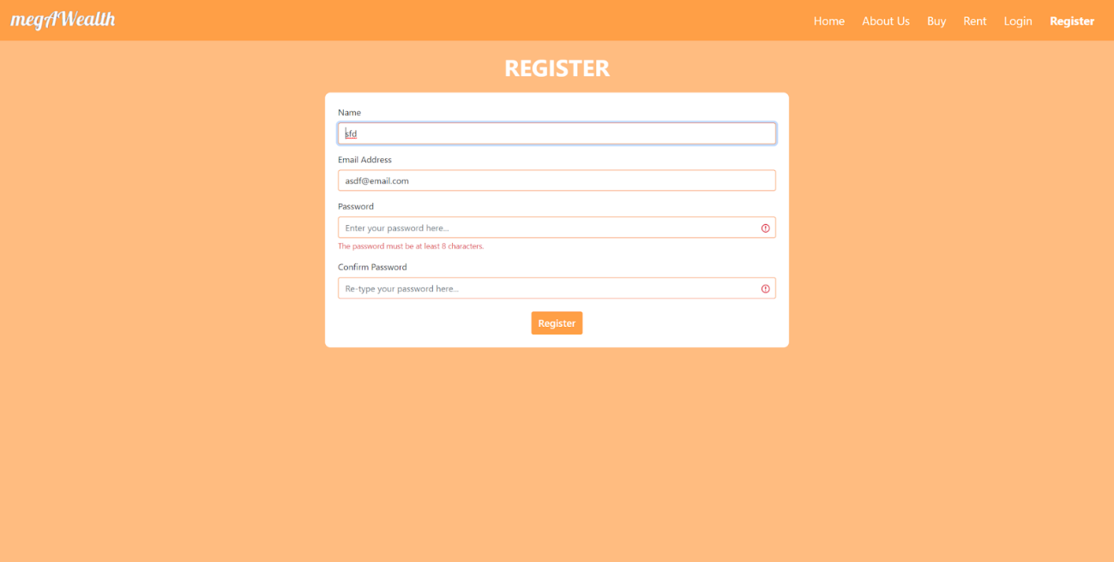

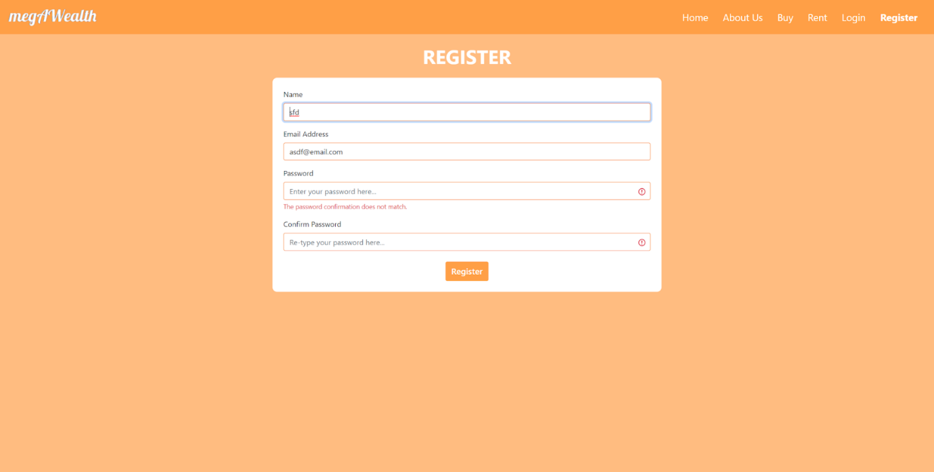

If the guests already pass all of the validations, the registration process is completed and they will be redirected to the login page with a register success message.

* 1. Login

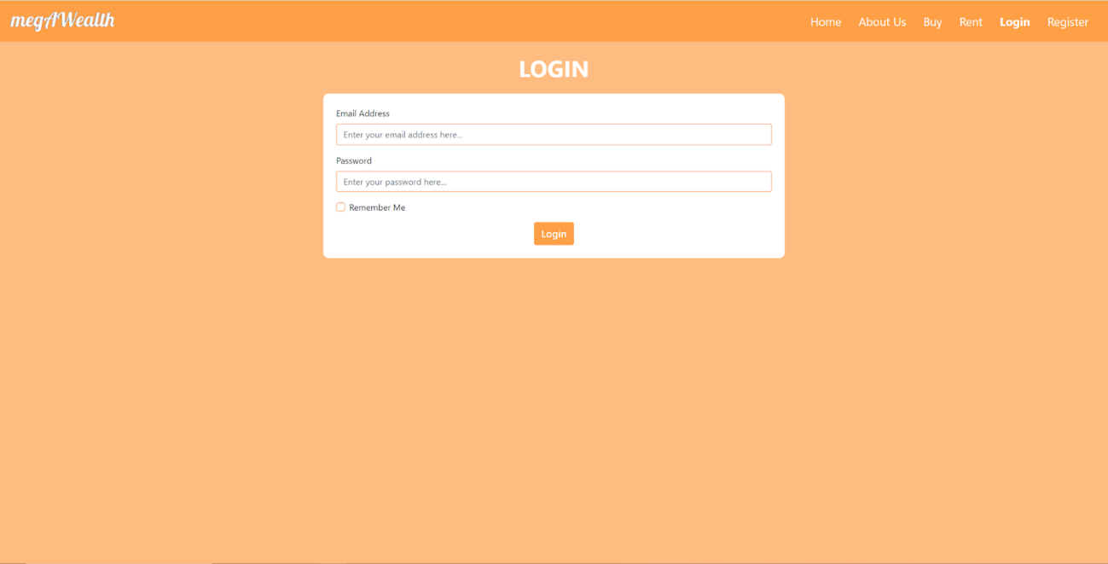

If the guests already have an account, they can directly go to the login page through the navbar and insert their credentials here. If they haven’t had any account, they can register first and then will be redirected to the login page again.

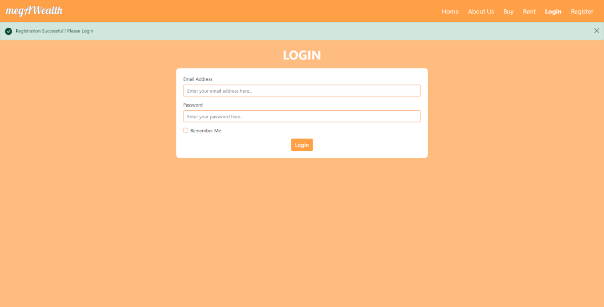

The guests can login to the application by filling their email address and password that has been registered before. Same with the registration form, the login form also has some input validations. All fields must be filled except for the remember me checkbox, the email inputted must be a valid email, and the password inputted must be at least 8 characters long. If they check the remember me checkbox, the web app will save the account in the cookie for five minutes. If the users logout in that five minutes range, they don’t need to type their email and password again, the web app already saves it in the cookie. After the guests’ inputs pass all the validations and the credential matches with the one that registered before, they will be redirected to the user’s home page. If the credentials are not matched, they will be redirected back to the login page and the web app will show a failed message.

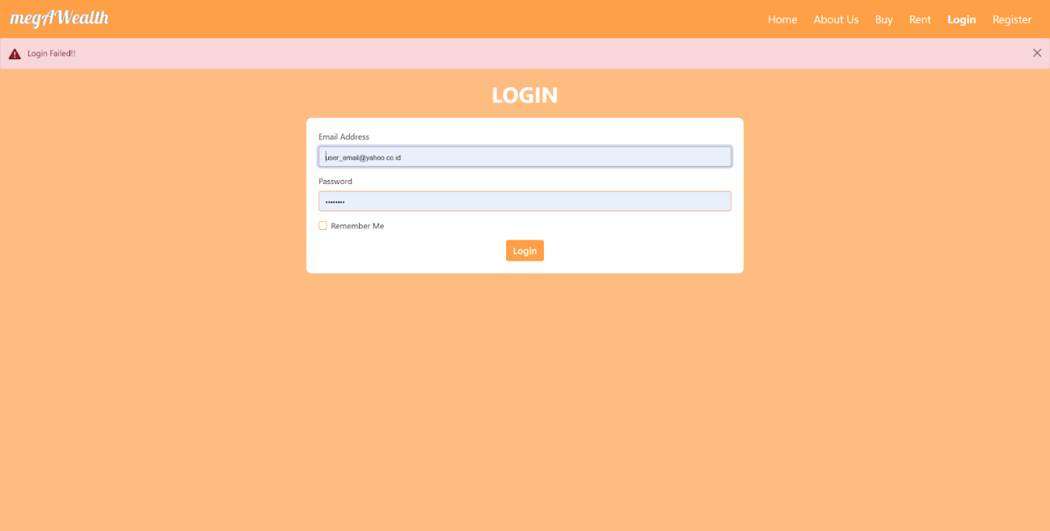

* 1. Home

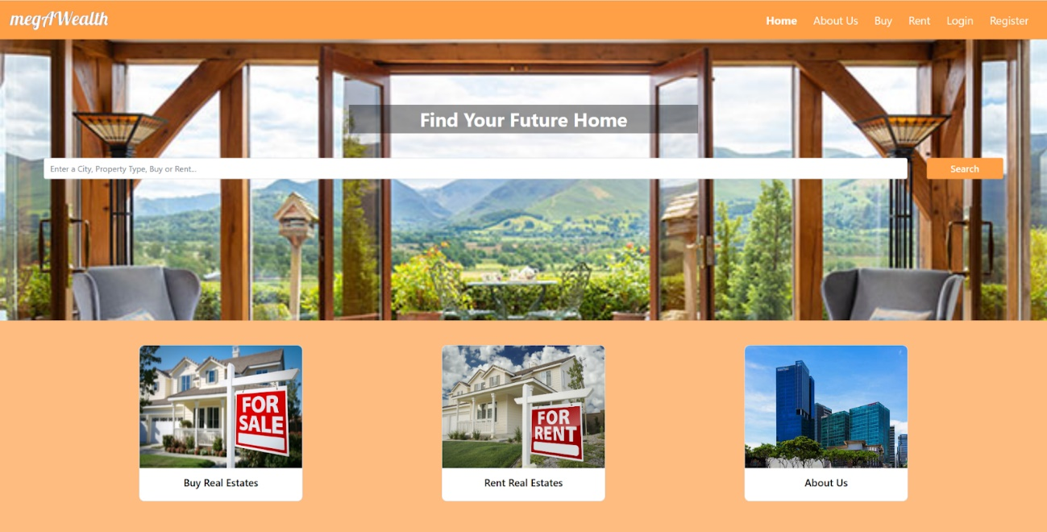

In the home page, guests can search the real estates that they want by inserting some keywords, like city, property type, or sales type in the search box. After typing the keywords and pushing the search button, they will be redirected to the search result page. In the bottom part of the page, there are three clickable cards that will redirect the guests to the other page, the first one will redirect them to the buy page, the second one will redirect them to the rent page, and the last one will redirect them to the about us page. Each of the three cards has a hover state that will change the card background color.

* 1. About Us

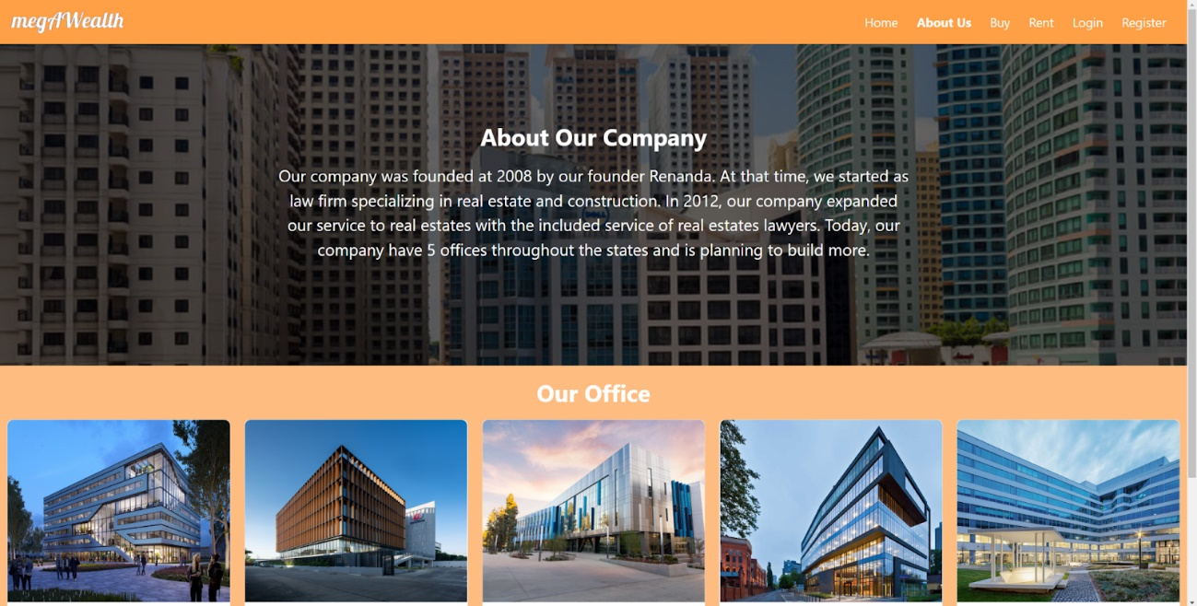

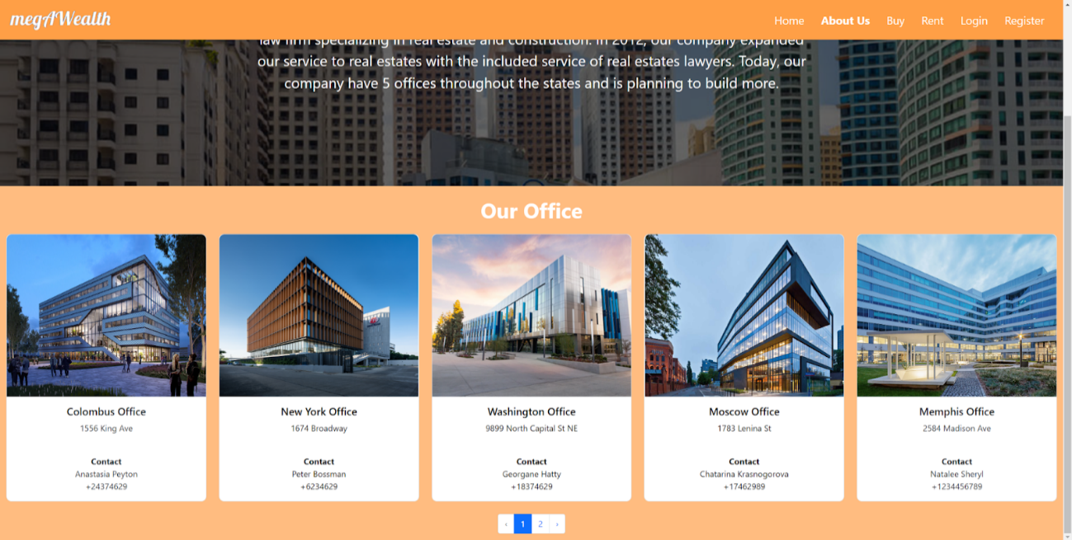

This page displays a short description of our company and shows all of the megAWealth offices address and contact in a card, paginated into five cards per page. The card also has a hover state that will change the card color. The guests can change the page by clicking the page numbers or arrows button in the bottom of the page.

* 1. Buy

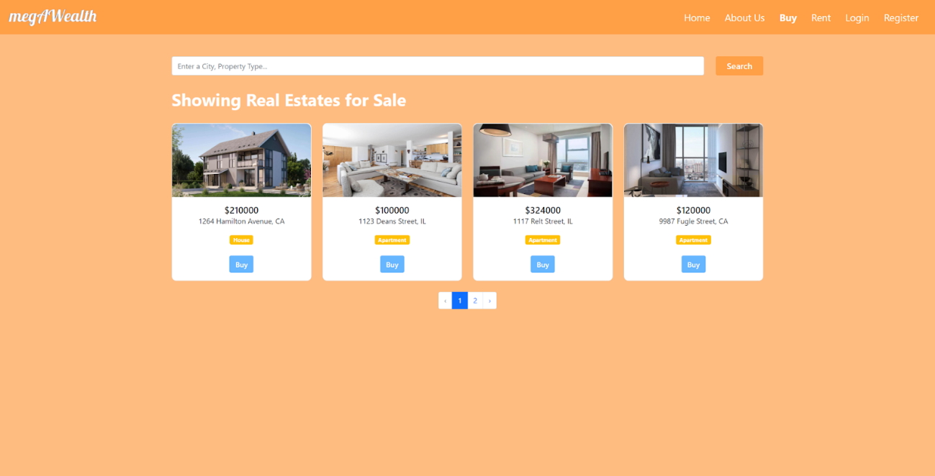

This page shows all of the real estates for sale, paginated into four real estates per page with the page numbers and arrows button in the bottom of the page. This page also has the same search box as the home page positioned in the top of the page, below the navbar. This search box will redirect the guests to the search result page and automatically search all real estate for sale only according to the guests’ input. Each real estate in this page provided some details like image, price, address, and building type. There is also a buy button for each real estate. if they click on the buy button, they will be redirected to the login page. If there are no real estates for sale, the page will display an empty message.

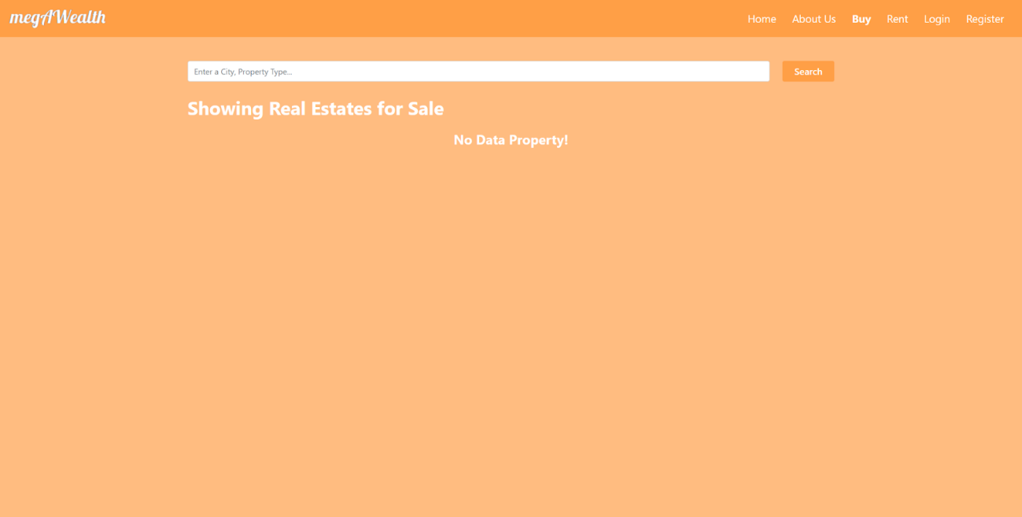

* 1. Rent

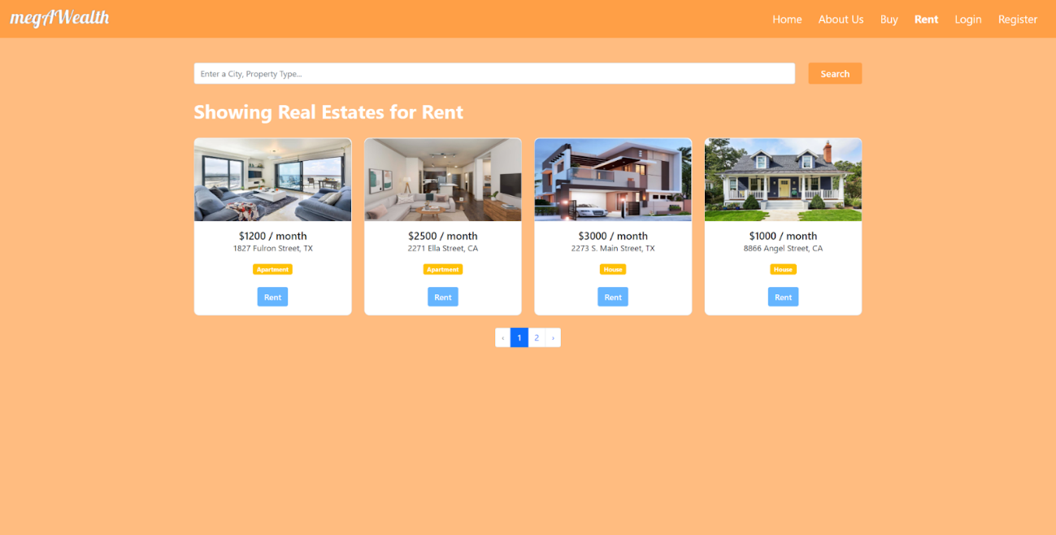

This page is apparently the same with the buy page, the differences are this page shows all real estates for rent instead of for sale, the button text is rent instead of buy, and there is an additional “ / month” text after the real estate’s price. The button functionality is also the same with the one in the guests’ buy page.

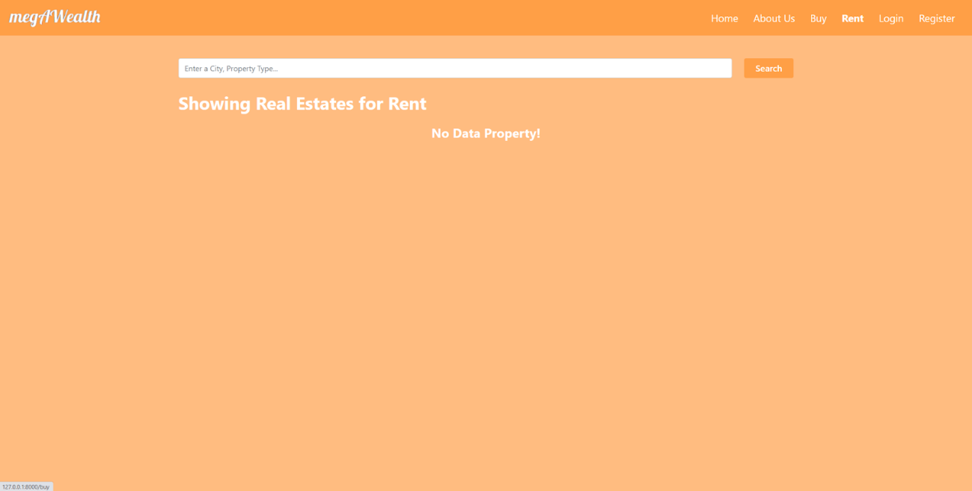

* 1. Search

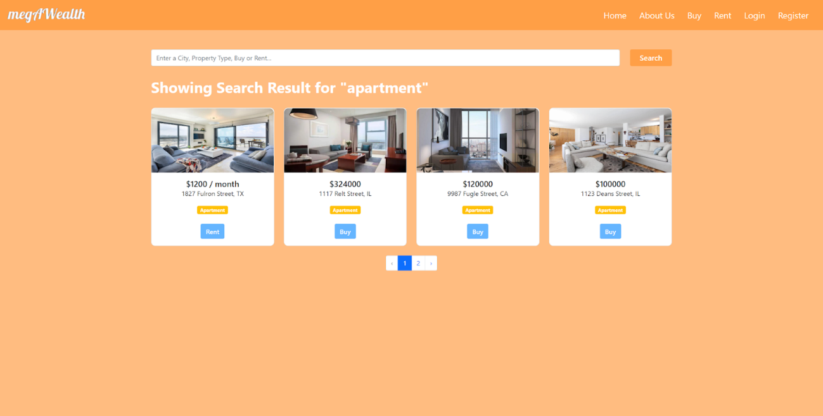

This page can be accessed when the guests submit the keywords in the search box. It will display the related real estate card like in the buy or rent page according to the sales type. If the sales type is rent, then the text “ / month” will be added and the button text will become rent. It also applies to the sale. If there is no property match with the keywords, the page will display an empty message.

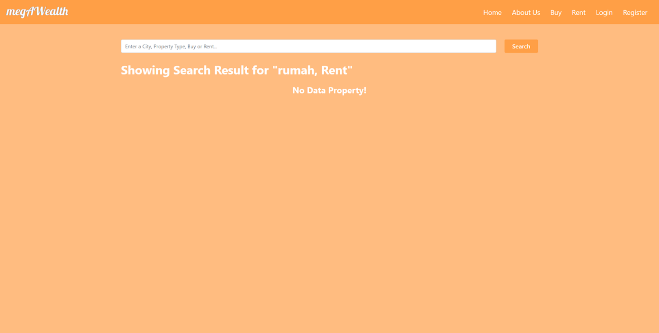

1. USER
   1. Home

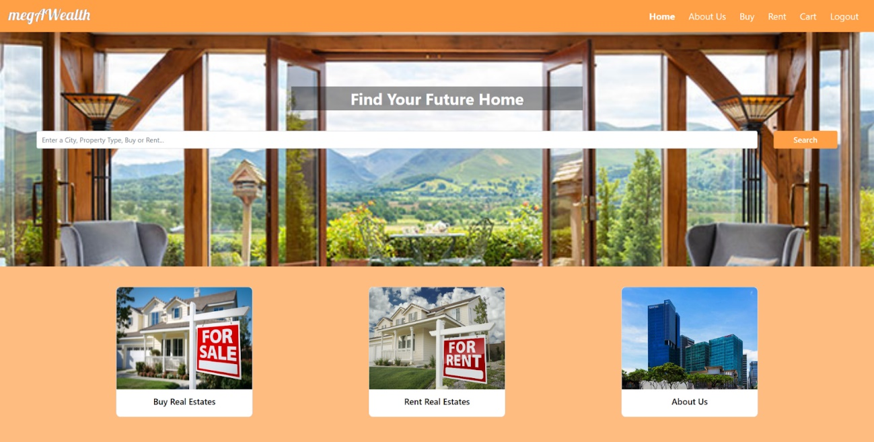

This page has the same view and functionality as the guests’ page. The difference between the guests’ page and the users’ page is in the navbar, where the guests’ navbar contain home, about us, buy, rent, login, and register. Meanwhile, the users' contain home, about us, buy, rent, cart, and logout. The navbar difference is applied to all of the pages.

* 1. About Us

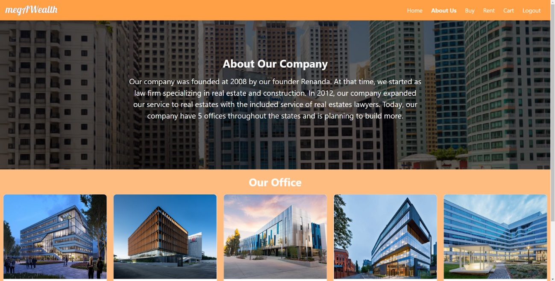

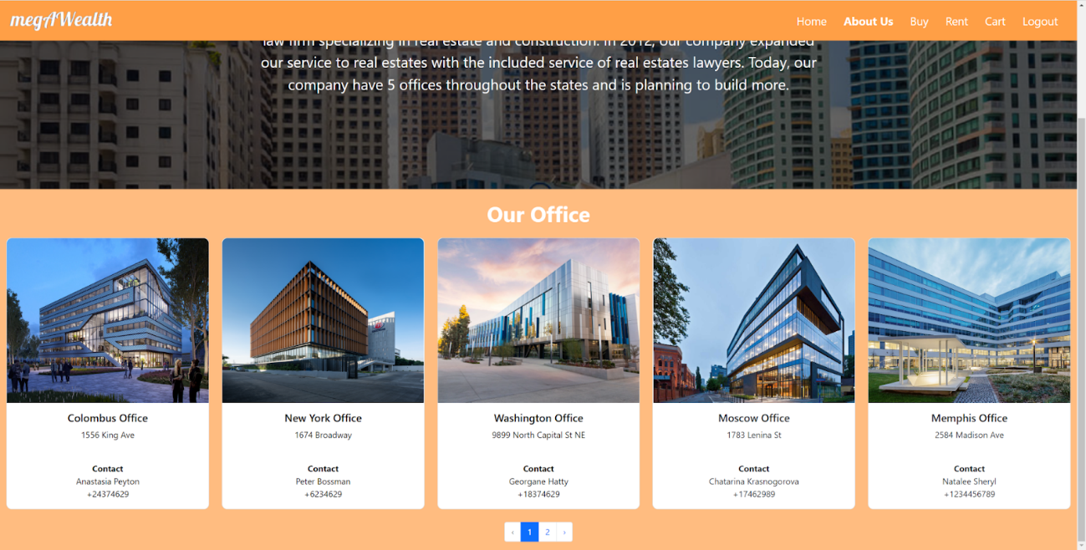

This page has the same view and functionality as the one in the guests’ page.

* 1. Buy

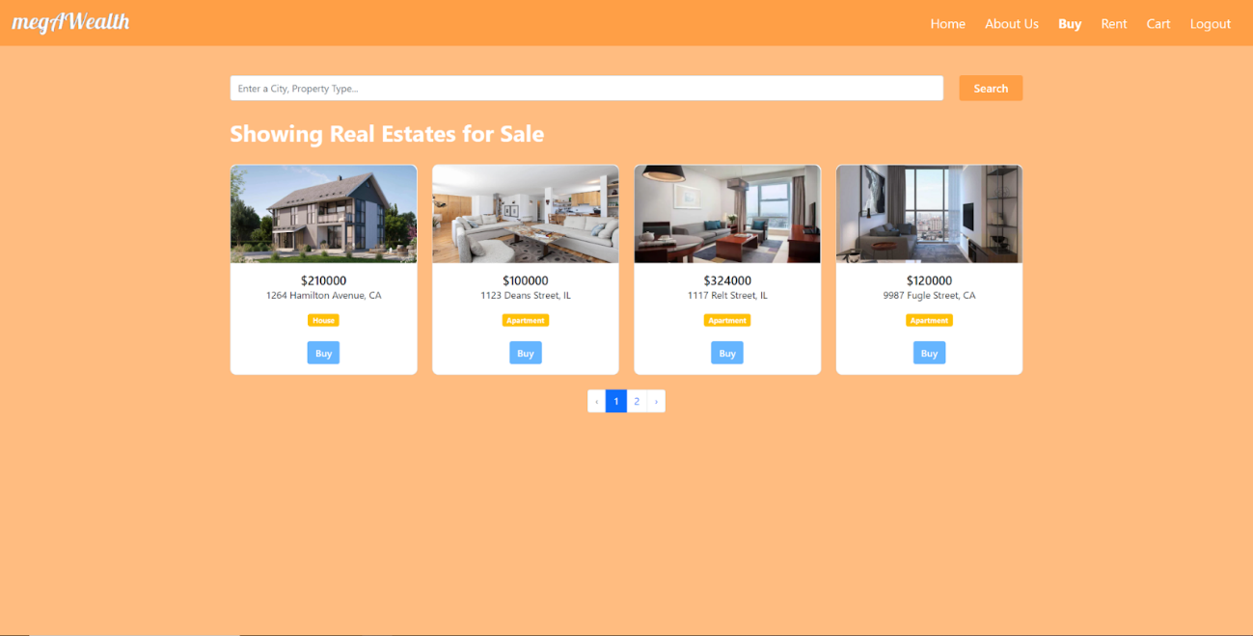

This page view has no difference with the one in the guests’ page, the difference is when the users hit the buy button, the real estate will be inserted to their cart and then the users will be redirected back to the buy page with a success message.

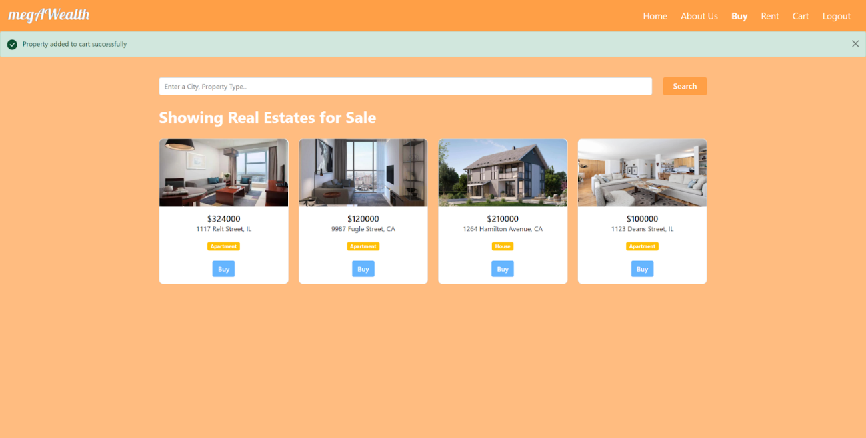

This page also displayed an empty message if there is no real estate for sale.

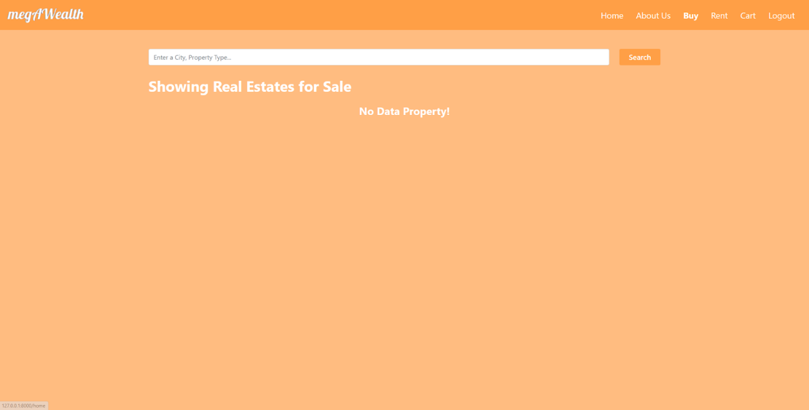

* 1. Rent

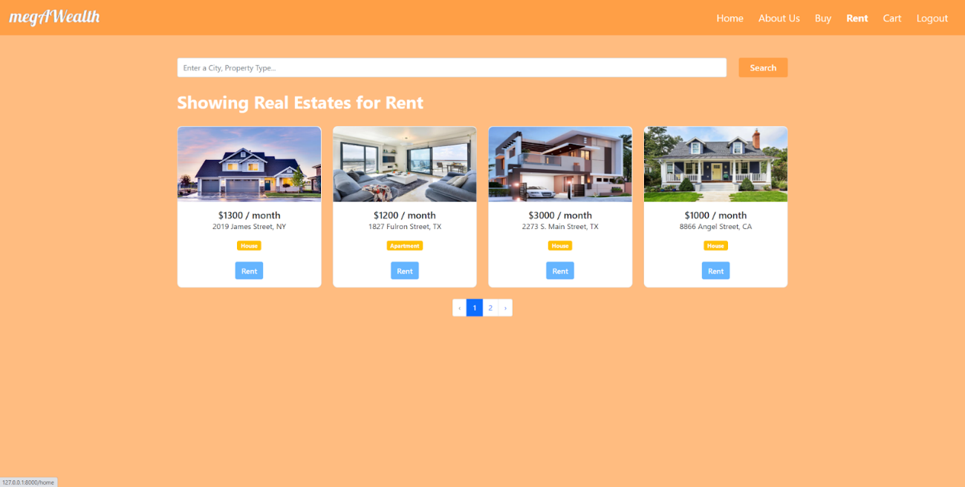

Same with the users’ buy page, the rent page has no different view with the guests’ rent page. The button functionality is also the same as the one in the users’ buy page.

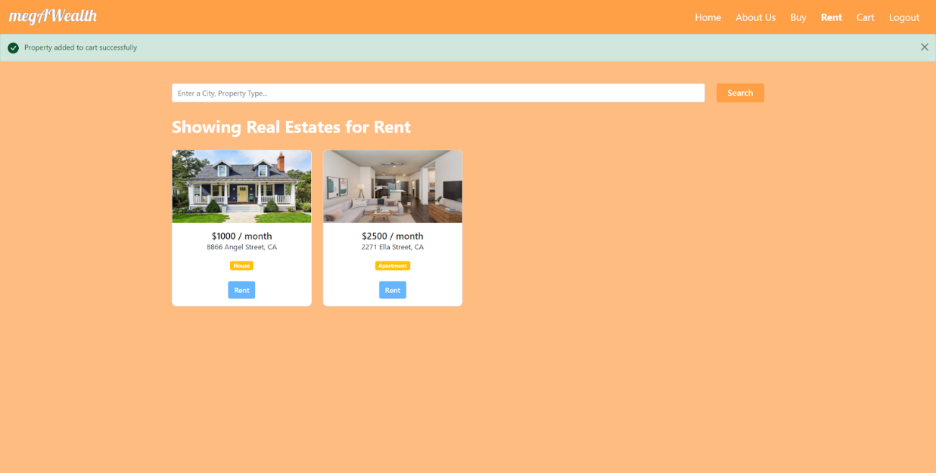

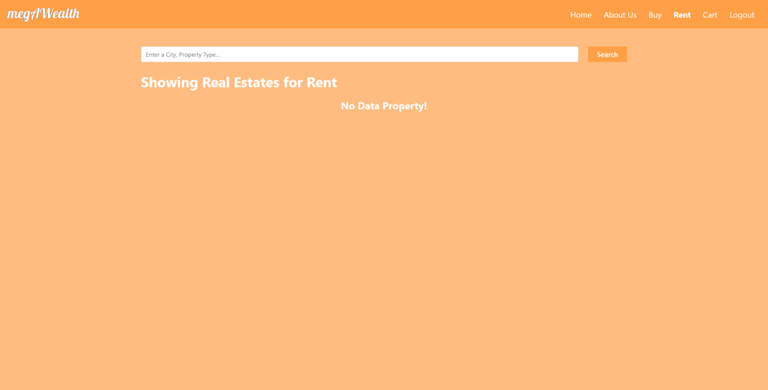

* 1. Cart

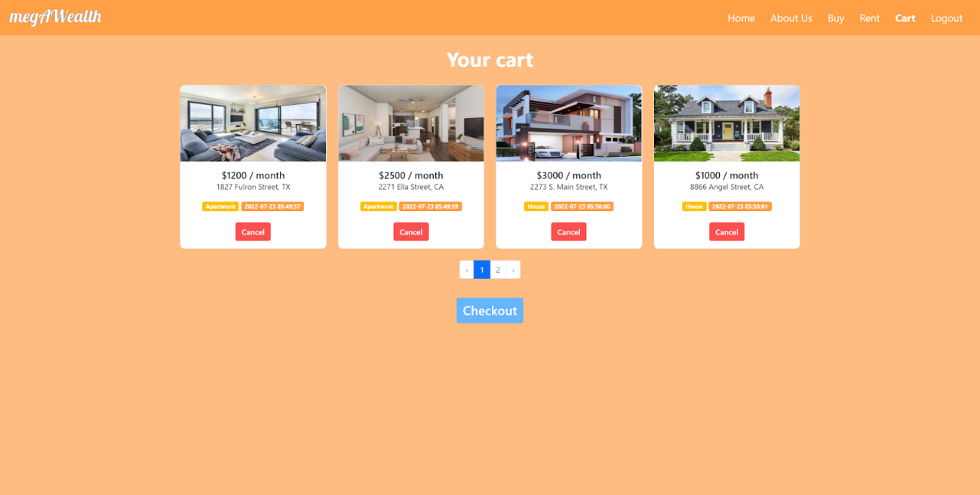

This page is only available for the users. In this page, they can see all of the real estate that they want to buy and rent, paginated into four real estates per page and a checkout button. The real estate card in this page is similar to the one in the buy or rent page. If the sales type is rent, the price text is added with “ / month” , there is also additional info about the date time of the real estate being put in the cart, and the rent or buy button is changed to cancel button to remove the real estates from the cart. If the users hit the cancel button, there will be an alert that shows and asks the users if they are sure to remove it. If they are sure, the users will be redirected back to the cart page with a success message. When the users hit the checkout button, the web app will remove all of the real estate data in the users’ cart and redirect the users to the home page with a success message. The web app will keep the transaction data in the database.

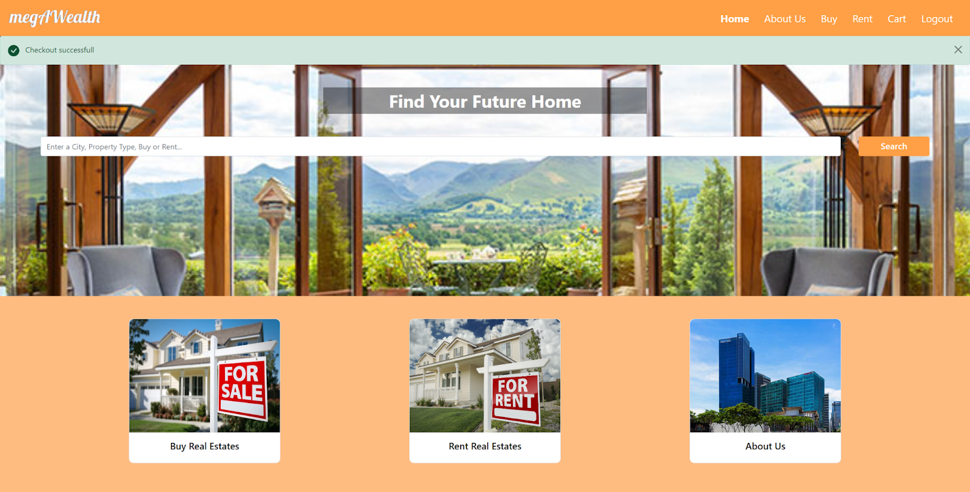

If the cart is empty, the web app also displays the empty message.

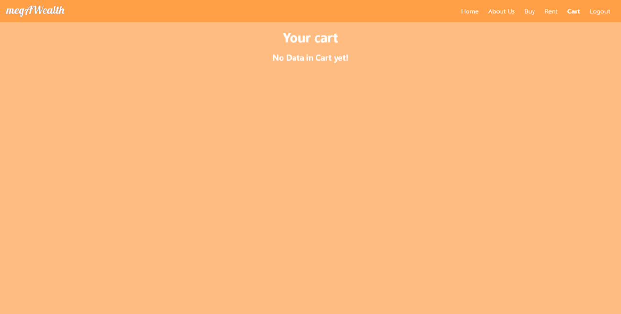

* 1. Search

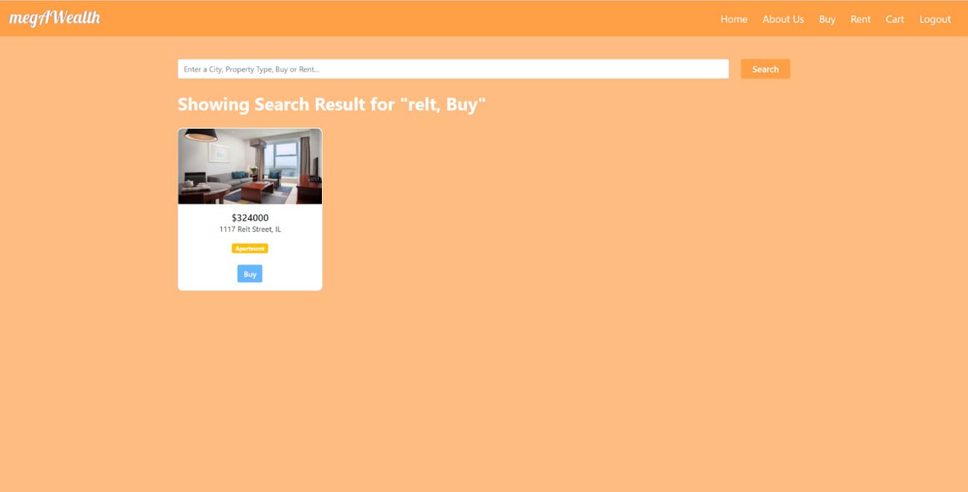

This page view has no difference with the one in the guests’ page. The difference is when the users hit the buy or rent button, the real estate will be added to the users’ cart and then the users will be redirected back to the search page with a success message.

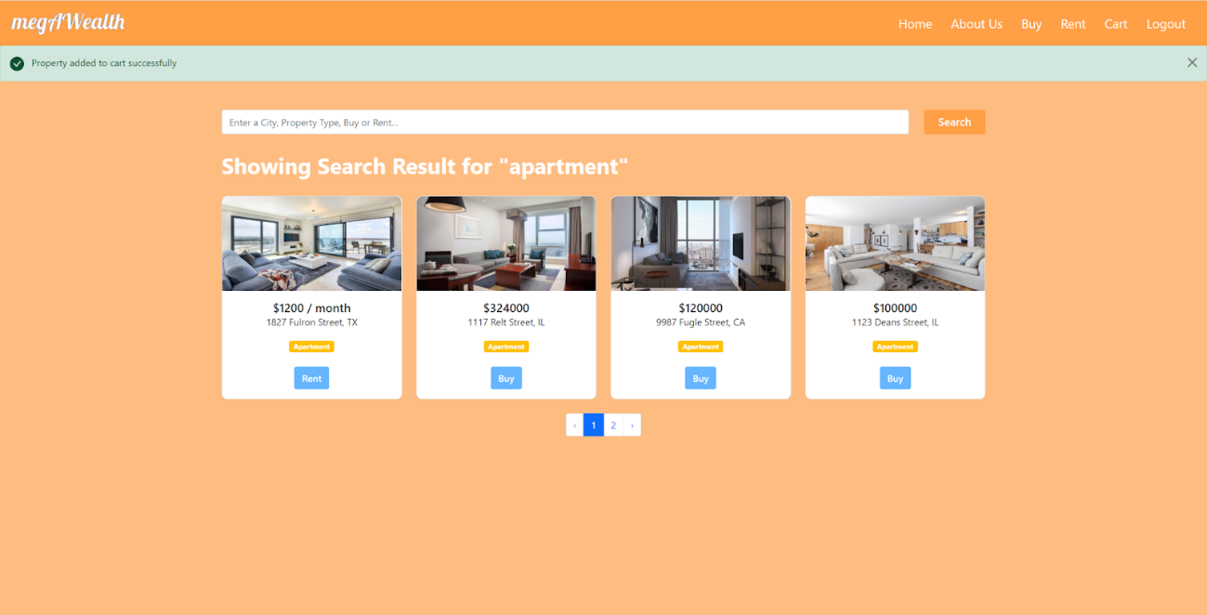

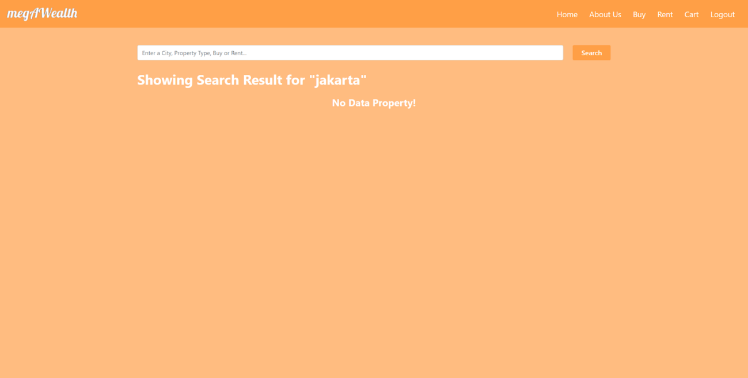

* 1. Logout

If the users hit the logout button in the navbar, they will be logged out and redirected to the login page. If they check the remember me checkbox and logout before five minutes, then their email and password are already there in the login form.

1. ADMIN
   1. Login

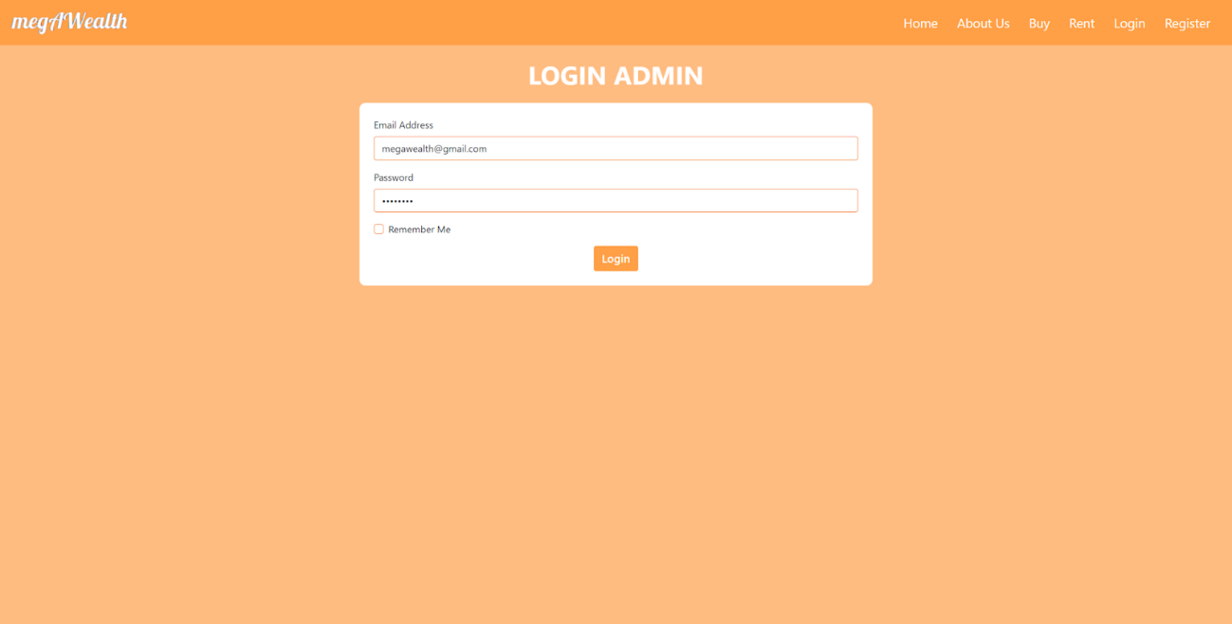

Admin’s login page has the same view and functionality with the guests’ login page. The difference is in the url, where guests’ login url is only “/login”, the admin’s login url is “/loginAdmin”. There is no button or text link that can redirect users to this url, to access it, admin must type the url manually.

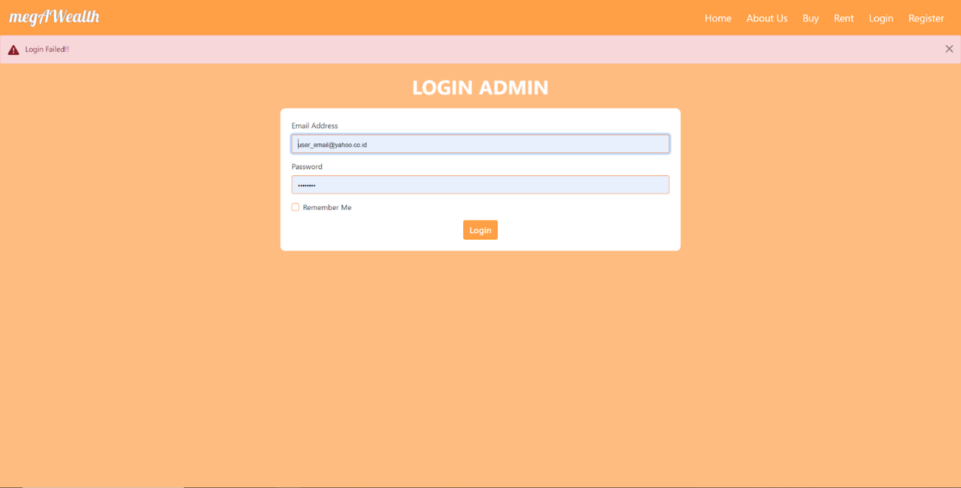

* 1. Home

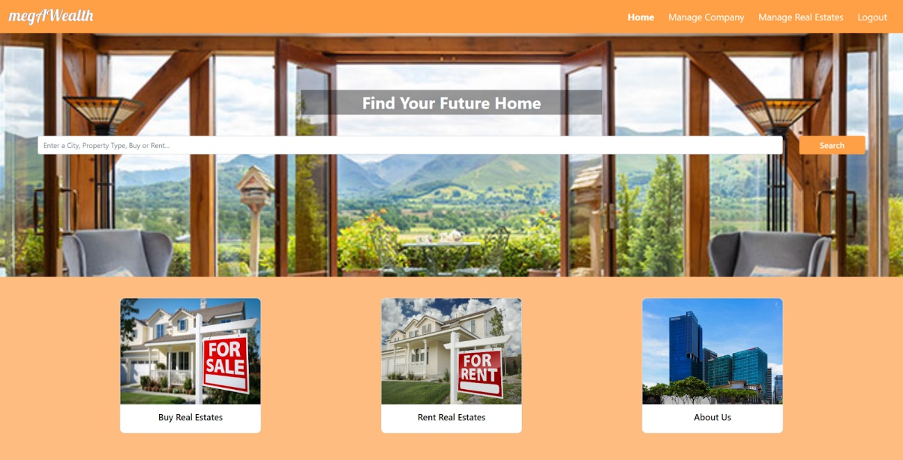

The view of this page is the same with the users’ and guests’ home page. Admin can also search on the search box and then will be redirected to the search result page. But, admin can’t access the buy, rent, and about us page through the card in the home page. The card still has a hover state but nothing happens when the admin clicks it. The navbar also differs with the guests’ and users’ navbar. Admin’s navbar consists of home, manage company, manage office, and logout. This navbar applied to all of the admin pages.

* 1. Manage Company

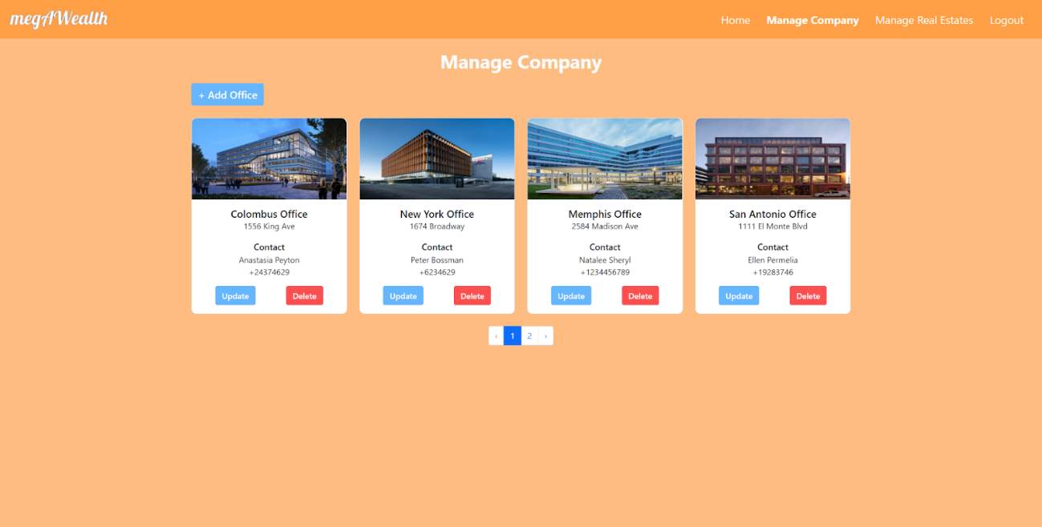

In this page, the admin can manage all of the office data that is displayed in the users’ and guests’ about us page. Each of the office data is displayed in a card and paginated into four cards per page. There is also an add office button that will redirect admin to the add office page. The office card is similar to the one in the about us page, but there are two additional buttons in the manage company page, that are update and delete buttons. If the admin hits the update button, he/she will be redirected to the update office page. If the admin hits the delete button, the web app will display an alert to confirm the action. If the admin is sure with his/her action, the web app will delete the office and redirect the admin back to the manage company page with a success message.

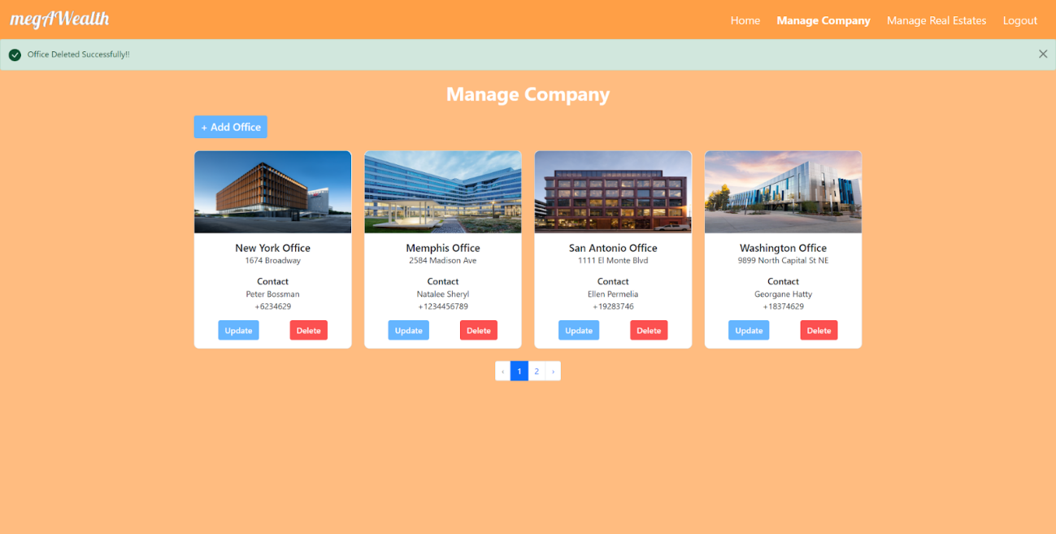

If there is no office data, the web app will display an empty message

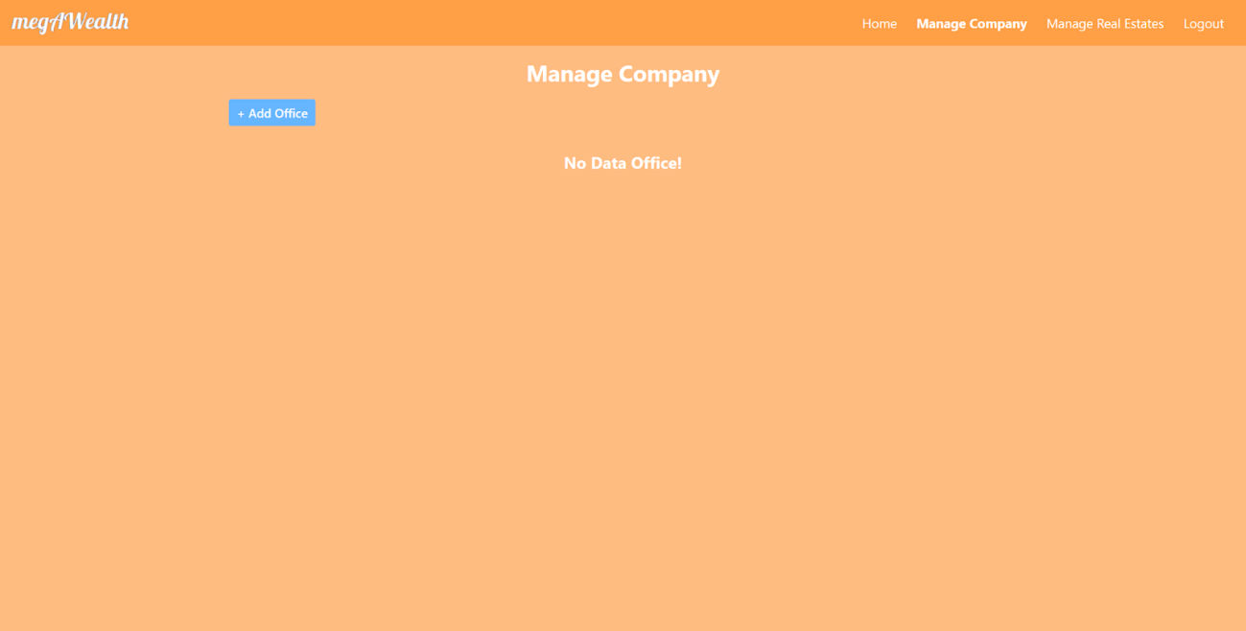

* + 1. Add Office

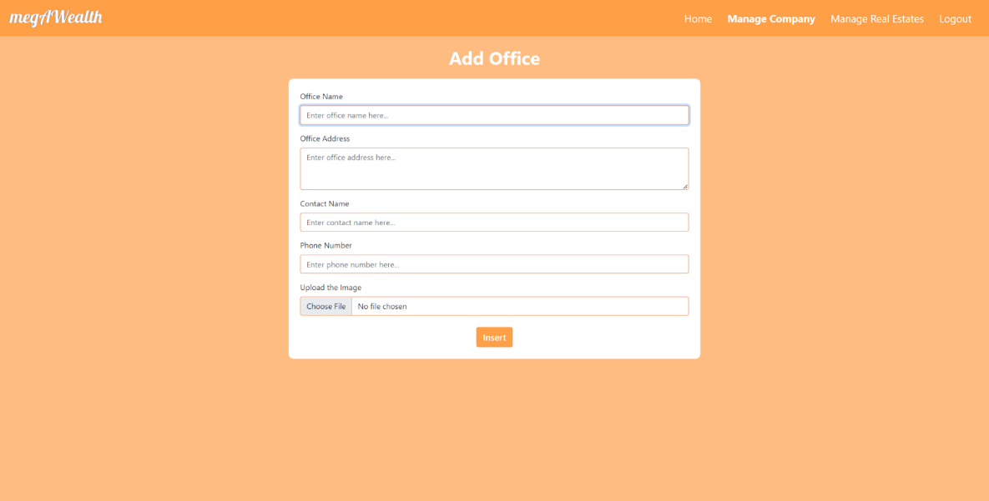

This page will display a form that must be filled if the admin wants to add a new office. If the admin didn’t fill all of the field, he/she will be redirected back to the add office page and display the error message.

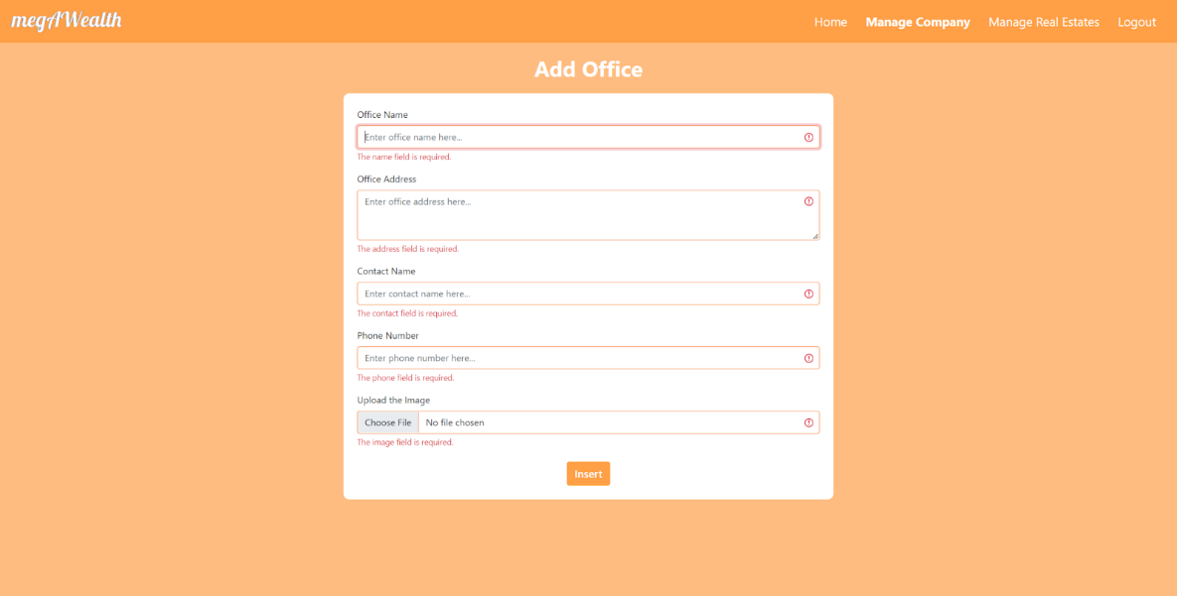

If all of the input is already filled, the web app will add the new office data and redirect the admin to the manage company page with a success message.

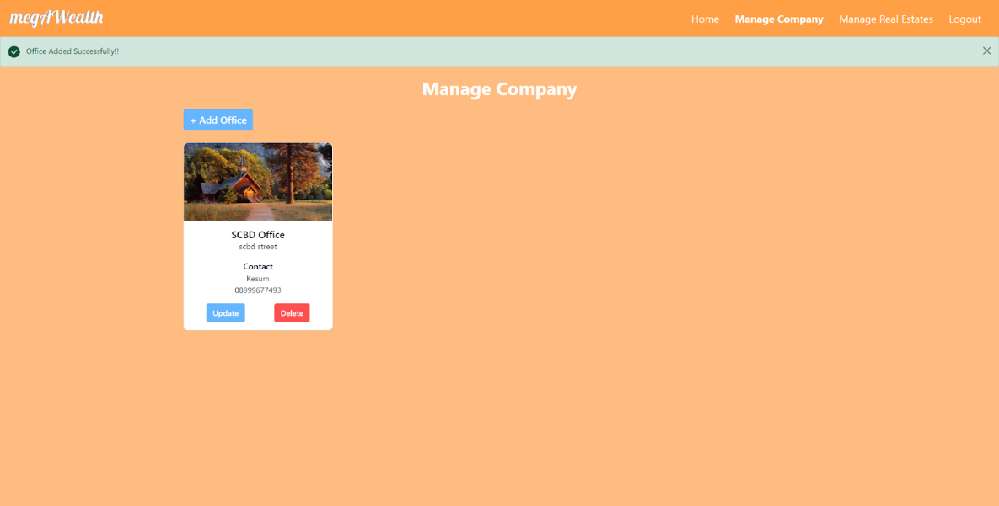

* + 1. Update Office

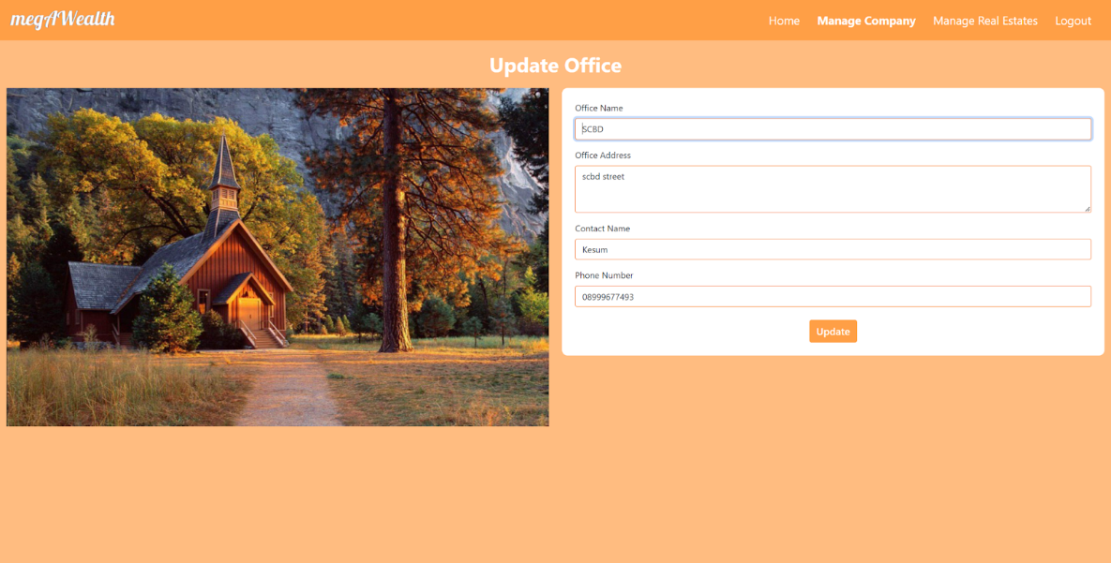

This page will display the previous office data and photo. Admin can change all data except the photo. He/she just needs to change the data written in the form and then press the update button. If there is an empty field in the form, the web app will redirect the admin to the update page again and give him/her error messages.

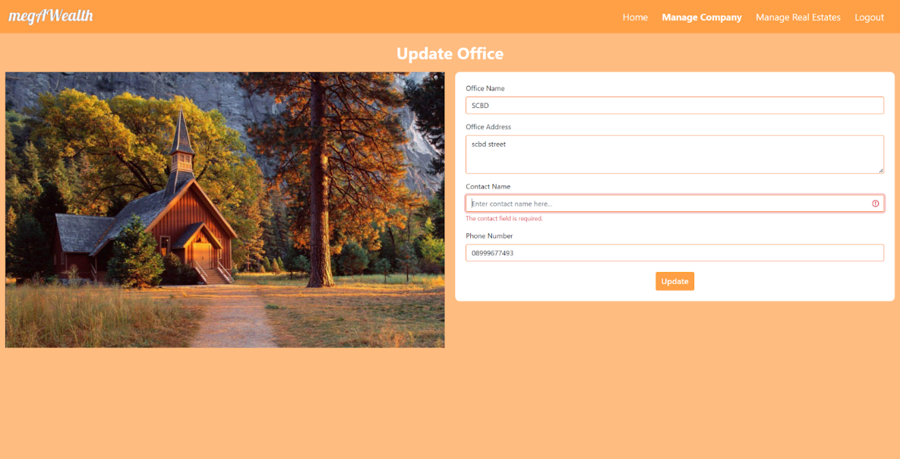

If all fields have been filled, the web app will update the office and redirect to the manage office page with a success message.

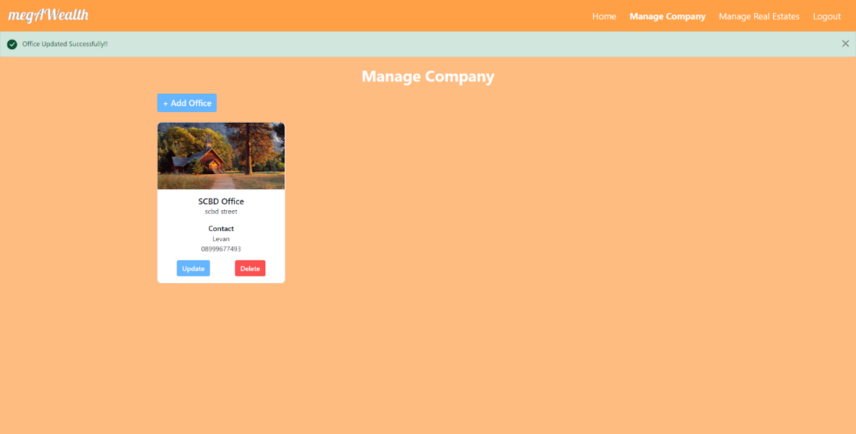

* 1. Manage Real Estate

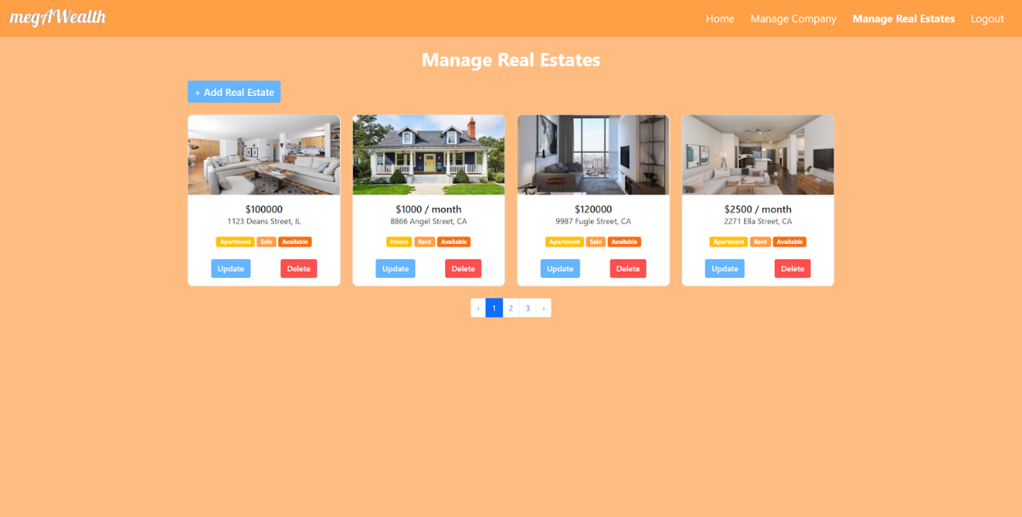

In this page, the admin can manage all of the real estate in this web app. The view is similar to the manage company page, each of the real estate is displayed in a card and paginated into four cards per page. The card is similar to the one in the users’ and guests’ search page, but there is some additional information given like the sales type and status. There are also an add real estate button that will redirect the admin to the add real estate page, an update button that will redirect admin to the update real estate page, and delete button that is the same with the one in the manage company page.

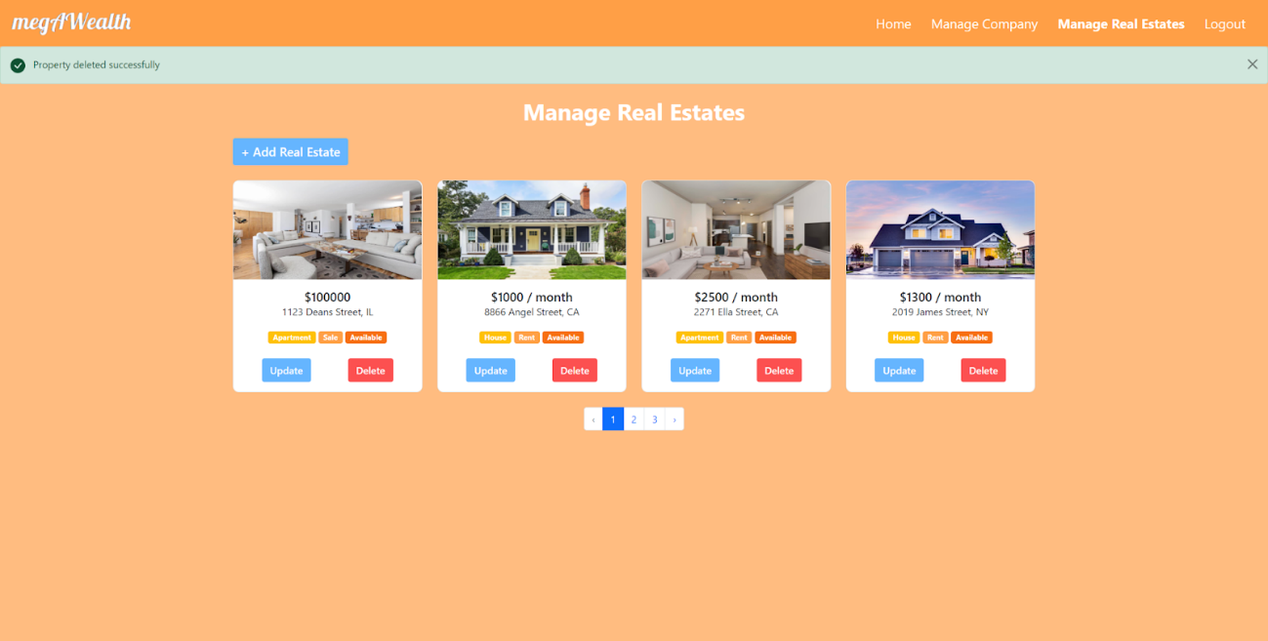

If the real estate status is booked or the real estate is in someone’s cart, the admin has another button in the card to finish the transaction.

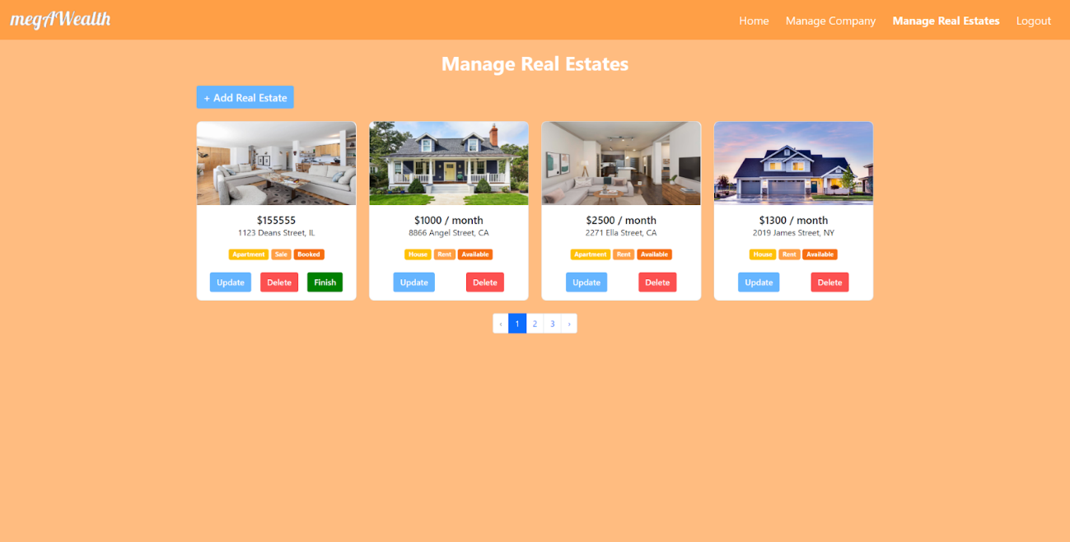

When the admin clicks the finish button, that real estate will be checked out from the corresponding user’s cart and the transaction recorded by the web app. The admin will be redirected back to the manage real estate page with a transaction success message.

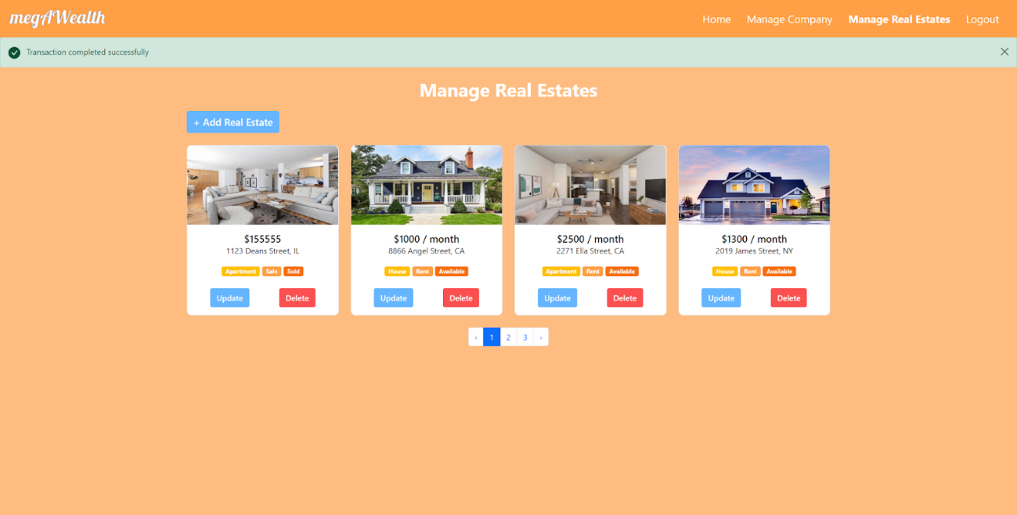

* + 1. Add Real Estate

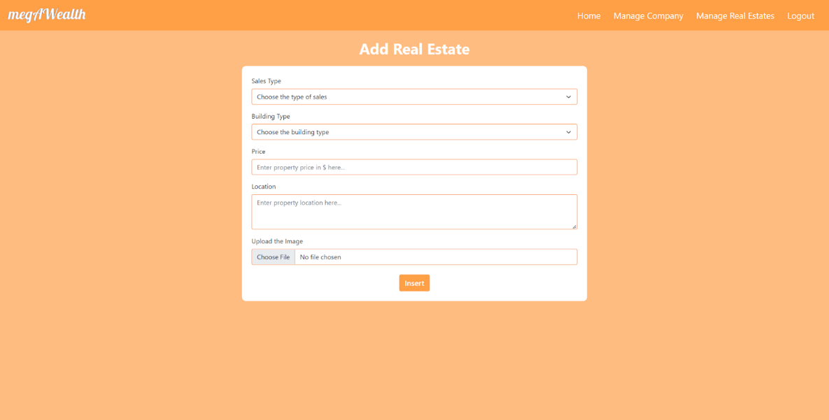

This page has the similar functionality with the add office page, it will show a form that needs to be filled to add a new real estate. If there is a field that haven’t been filled, the web app will redirect the admin back to the add real estate page with the error message.

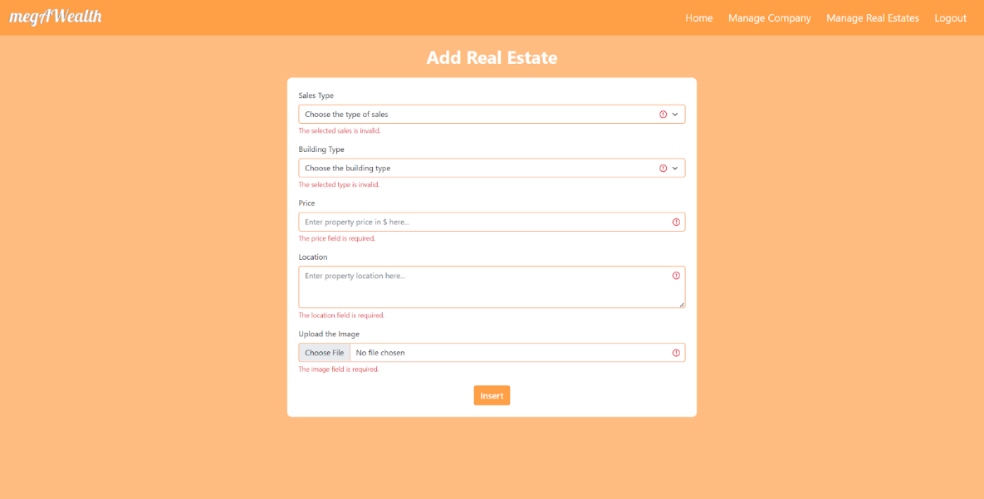

If all fields have been filled, the web app will store the new real estate and redirect the admin to the manage real estate page with a success message.

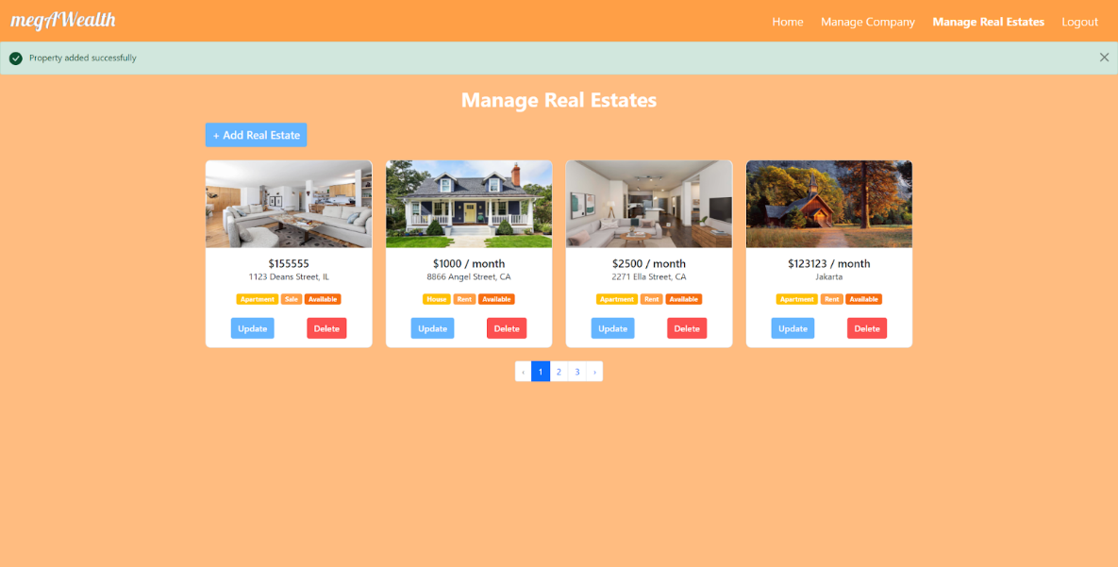

* + 1. Update Real Estate

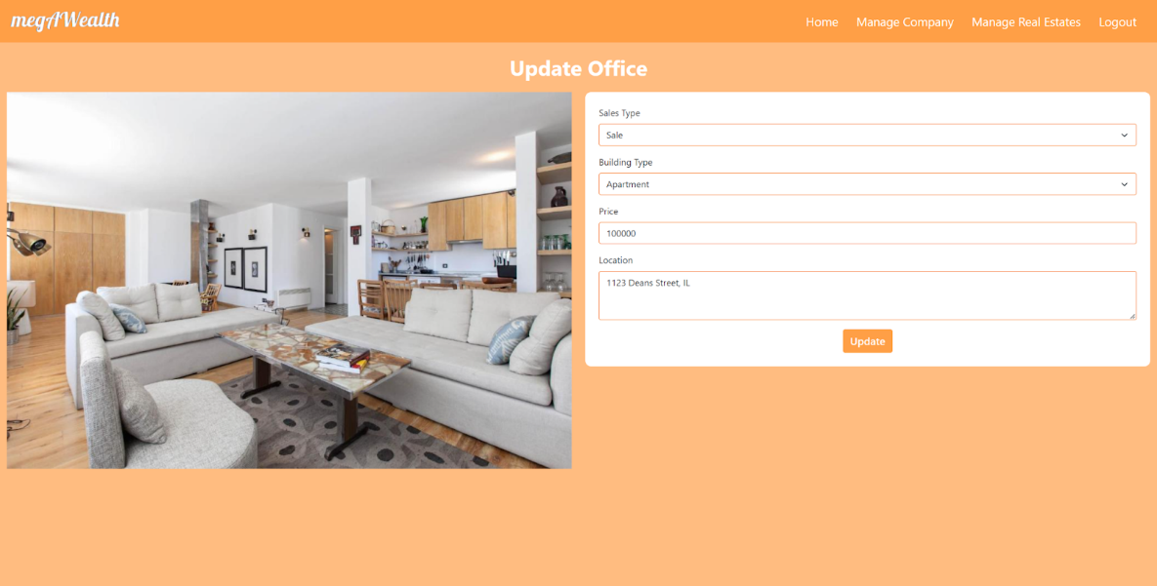

This one is also similar to the update office page, if there are some fields that haven’t been filled, then it will show the error messages, if the fields are already filled, then it will redirect the admin to the manage real estate page with a success message.

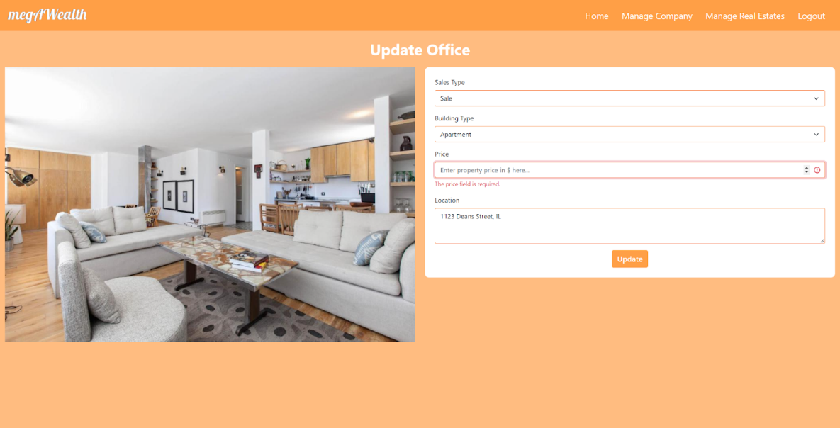

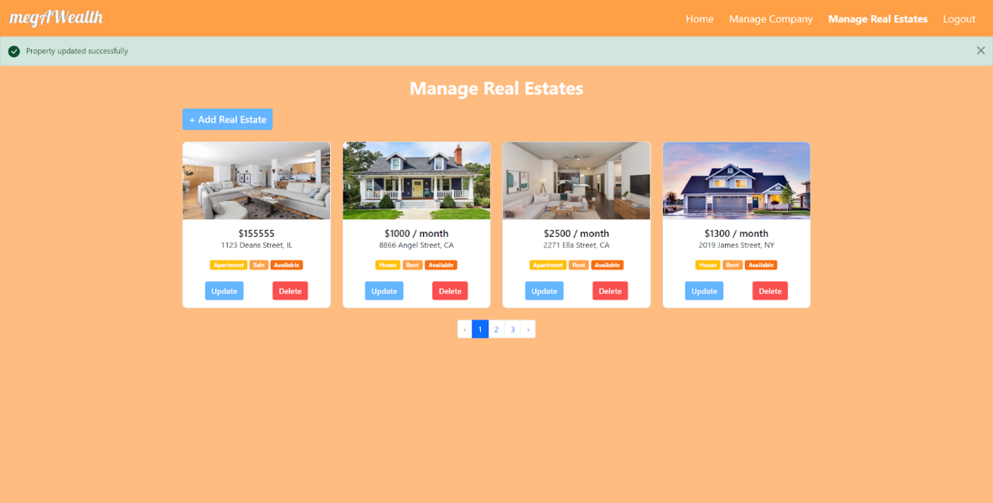

* 1. Search

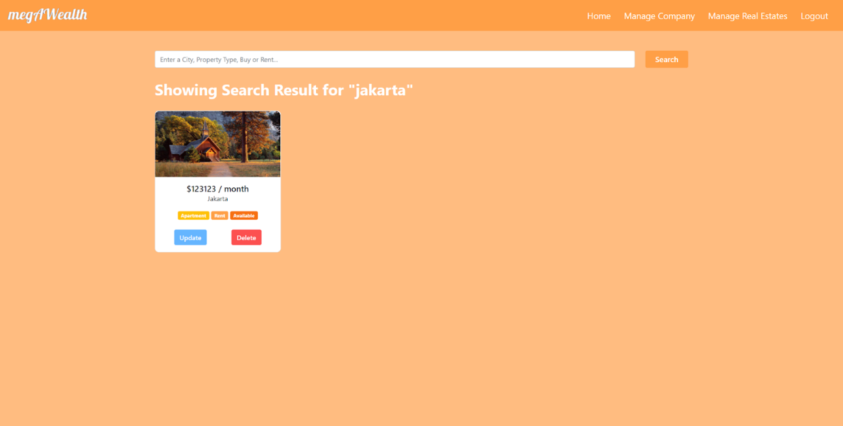

The functionality is the same with the search result page in users’ and guests’ page. But the card is similar to the one in the manage real estate page. If the admin hits the update, delete, or finish button, it will perform the same thing as in the manage real estate page. But the admin will be redirected to this search page instead of the manage real estate page if there is a complete action.

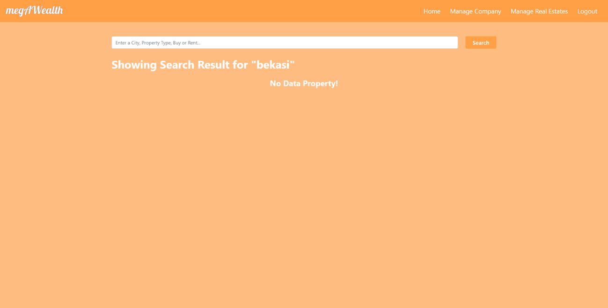

* 1. Logout

If the admin hits the logout button in the navbar, he/she will be logged out and redirected to the login admin page. If he/she checks the remember me checkbox and logout before five minutes, then the email and password are already there in the login form.

1. API
   1. Register Endpoint

This endpoint will provide user registration feature. The guests must provide their name, email, and password. All fields must be filled, the email must be a valid email, and the password must at least 8 characters long. If the inputs pass the validations, the web app will generate success message. Otherwise, the web app will provide the error messages.

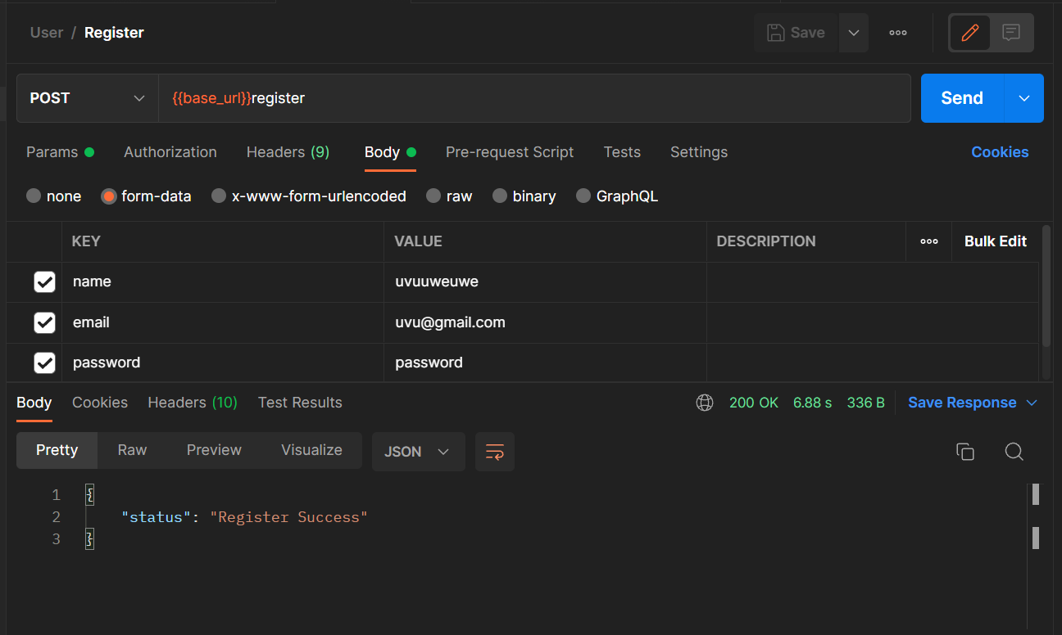

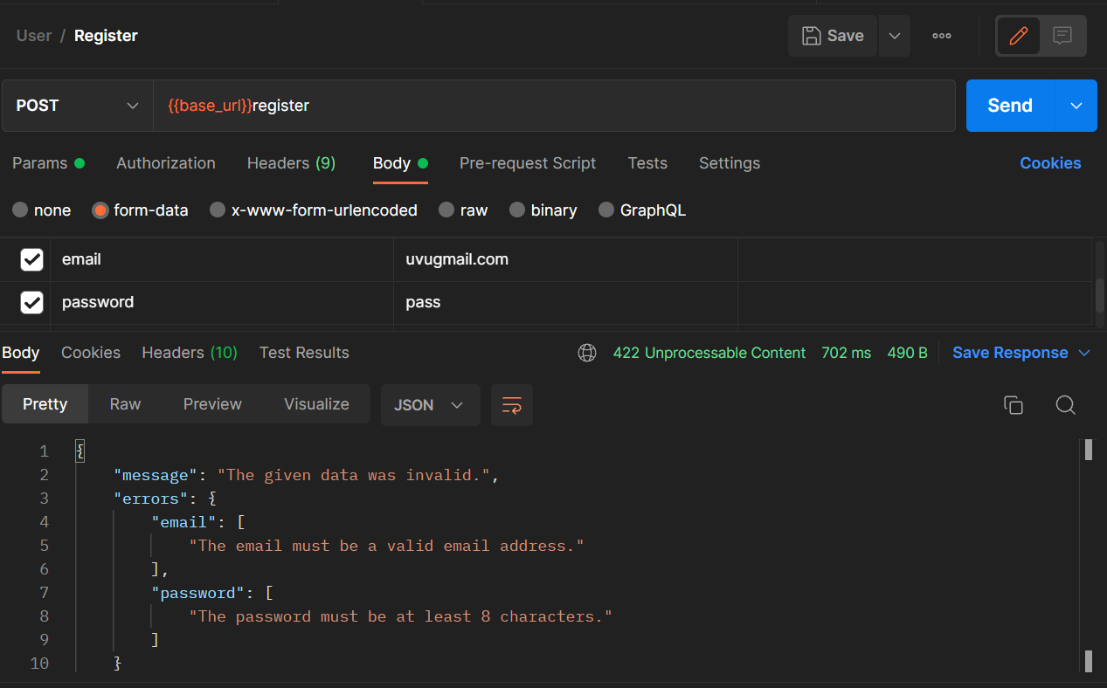

* 1. Login Endpoint

This endpoint will provide user login feature. To login, the guests must provide the registered email and password. If the email is a valid email, the password is minimal 8 characters long, and the email and password are match, the web app will show the success message and a bearer token. Otherwise, the web app will show the error messages.

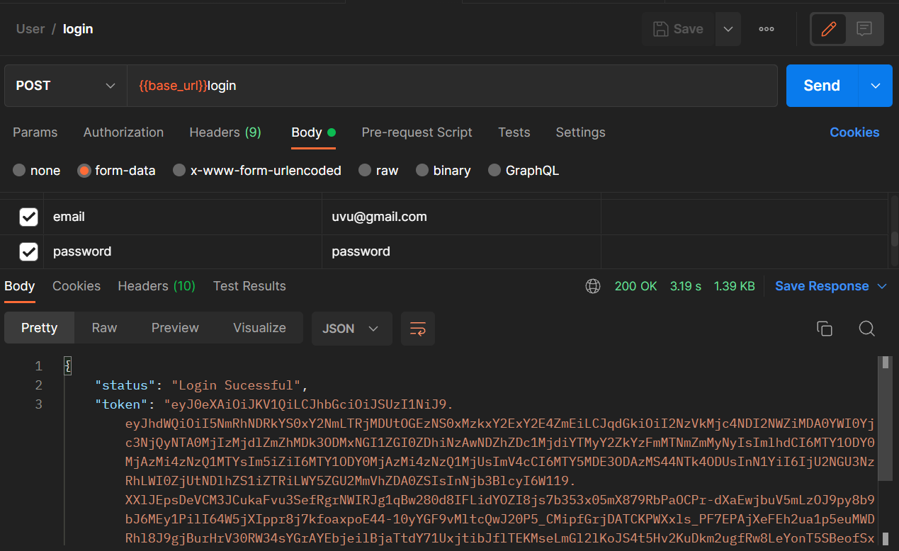

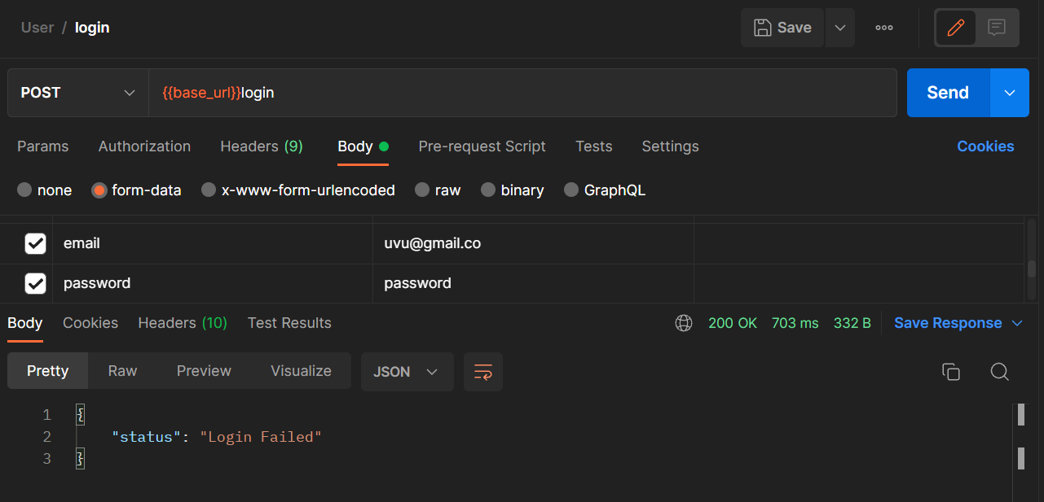

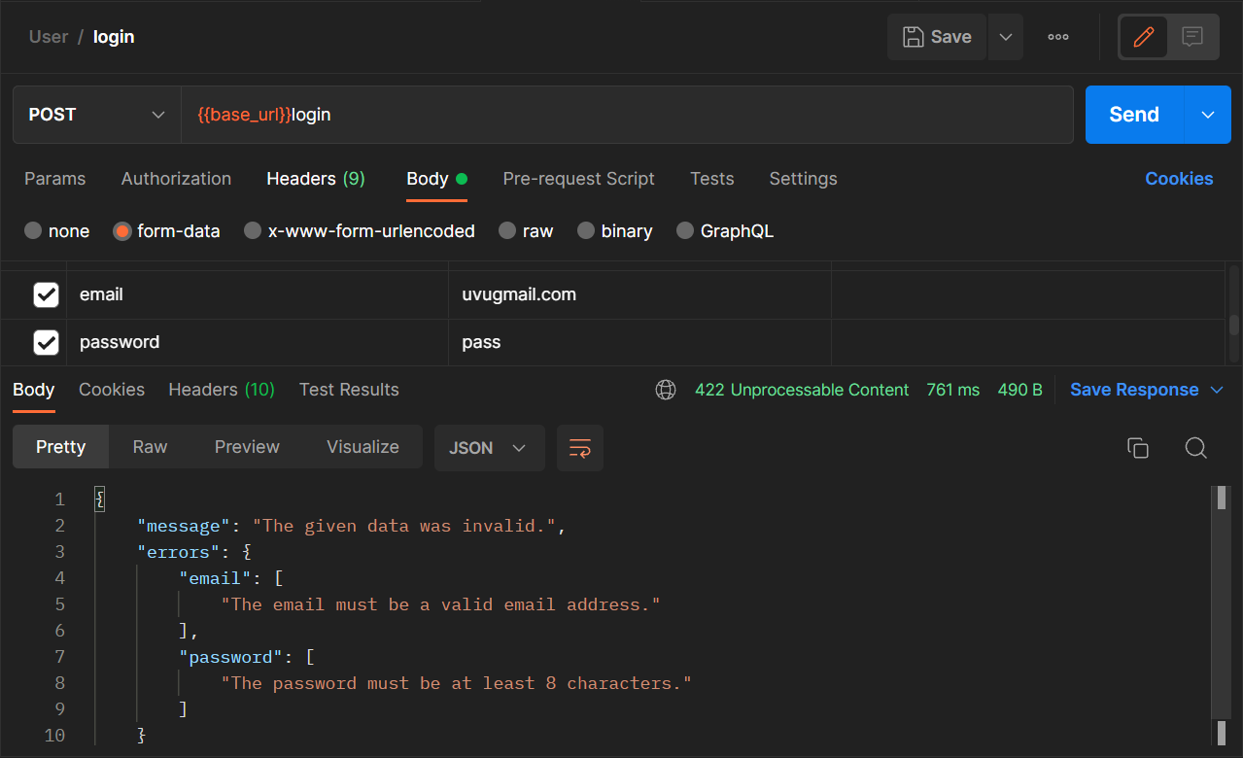

* 1. Transaction Endpoint

This endpoint provided the access to the transaction data of a specific user. The users must provide the bearer token received when login and their email to see the transaction. If the email isn’t valid or unauthenticated, the web app will provide the error messages.

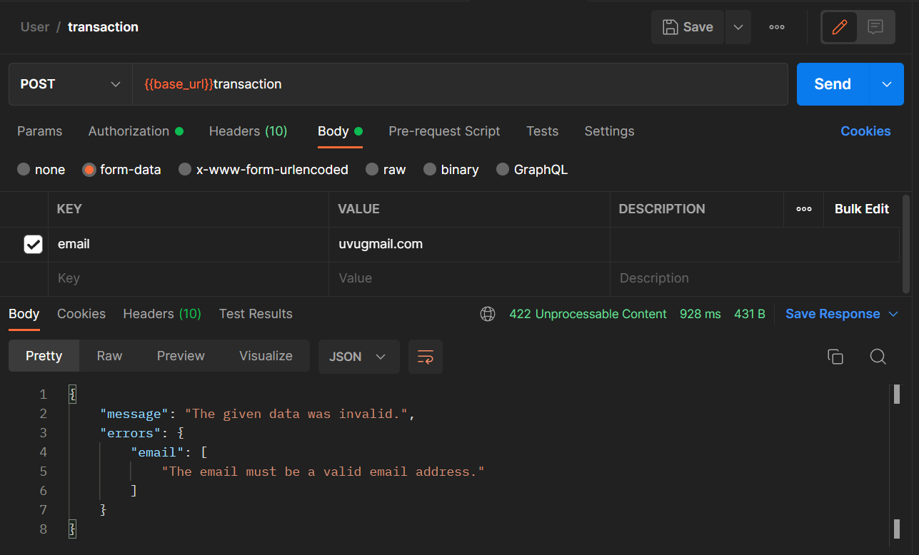

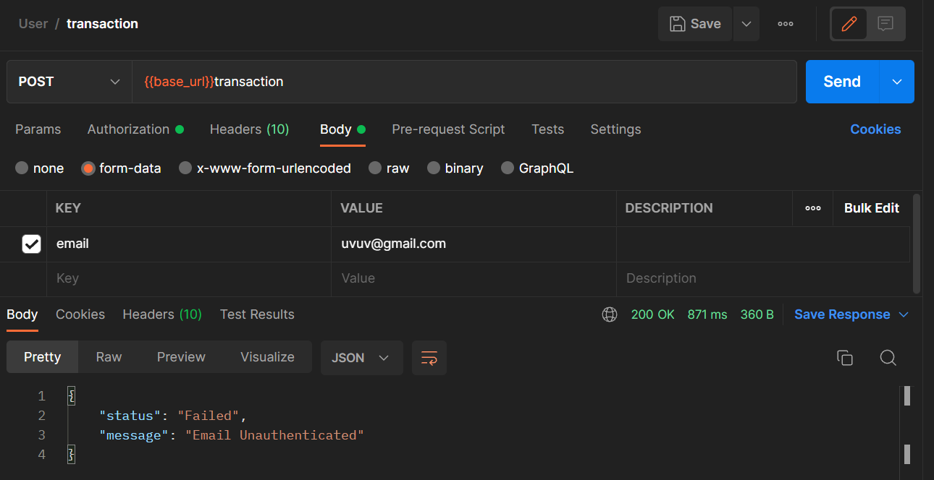

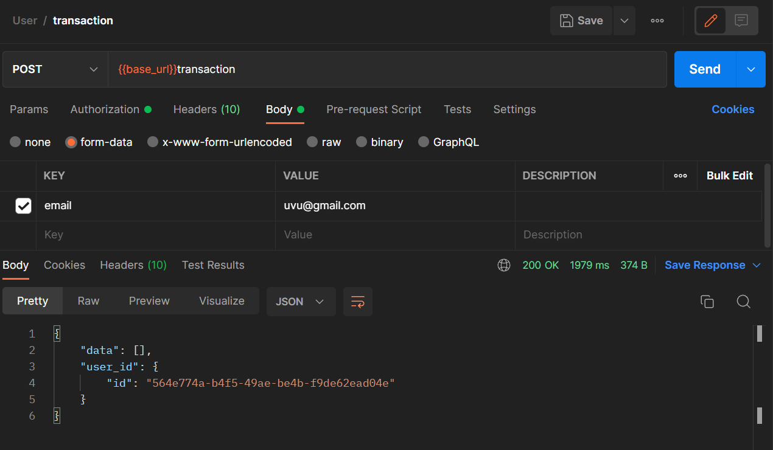

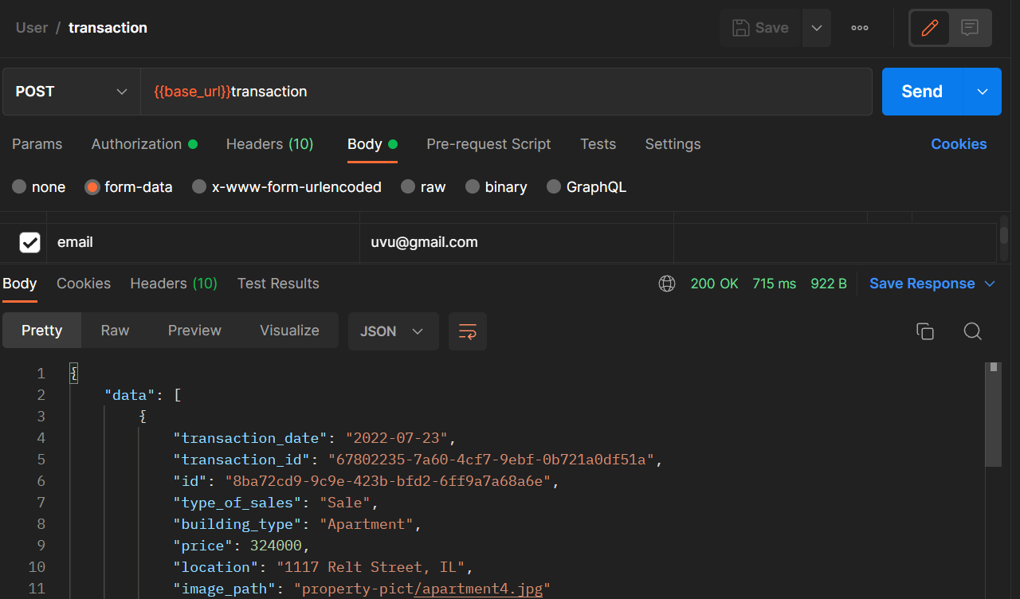

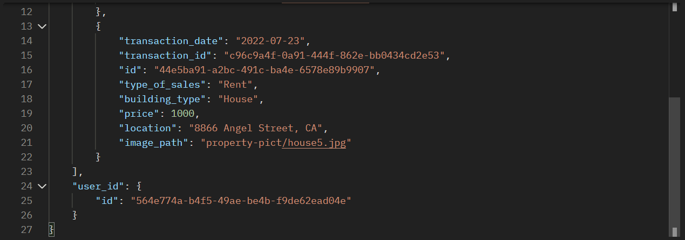

* Reference
* Home
  + <https://keyassets.timeincuk.net/inspirewp/live/wp-content/uploads/sites/8/2018/09/view6-1.jpg>
  + <https://assets.entrepreneur.com/content/3x2/2000/20150622231001-for-sale-real-estate-home-house.jpeg?auto=webp&quality=95&crop=16:9&width=675>
  + <https://sewa-apartemen.biz/wp-content/uploads/2019/02/for_rent.jpg>
  + <https://megaworld-pe8k1ip.stackpathdns.com/sites/default/files/2018-06/4mayimg1_0.JPG>
* Properties
  + <https://images.pexels.com/photos/106399/pexels-photo-106399.jpeg?auto=compress&cs=tinysrgb&dpr=1&w=500>
  + <https://cf.bstatic.com/xdata/images/hotel/max1024x768/72282092.jpg?k=5eeba7eb191652ce0c0988b4c7c042f1165b7064d865b096bb48b8c48bf191b9&o=&hp=1>
  + <https://images.ctfassets.net/pg6xj64qk0kh/2r4QaBLvhQFH1mPGljSdR9/39b737d93854060282f6b4a9b9893202/camden-paces-apartments-buckhead-ga-terraces-living-room-with-den_1.jpg>
  + <https://cf.bstatic.com/xdata/images/hotel/max1024x768/267316381.jpg?k=86b64cf28cd12f4c6feb7b7be23c8bcce91b2cd1be7c48a7383c4297d8d695ce&o=&hp=1>
  + <https://www.letsmoveindonesia.com/wp-content/uploads/2020/07/photo-family-room-ciputra-world-2-apartment-desain-arsitek-oleh-cross-space-interior-1024x570.jpeg>
  + <https://images.unsplash.com/photo-1564013799919-ab600027ffc6?ixlib=rb-1.2.1&ixid=MnwxMjA3fDB8MHxjb2xsZWN0aW9uLXBhZ2V8MXw5NjcyNDA1fHxlbnwwfHx8fA%3D%3D&w=1000&q=80>
  + <https://ik.imagekit.io/tvlk/blog/2020/04/The-Mayflower-Jakarta-Marriot-Executive-Apartments.jpeg?tr=dpr-1,w-675>
  + <https://q4g9y5a8.rocketcdn.me/wp-content/uploads/2020/02/home-banner-2020-02-min.jpg>
  + <https://i.pinimg.com/originals/66/d9/f5/66d9f5afdc5337d3f9eac362b970c426.jpg>
  + <https://cdn.vox-cdn.com/thumbor/LzDafgfNyCwGKtvBEe95EbFtUz8=/0x0:3686x2073/1220x813/filters:focal(1549x743:2137x1331):format(webp)/cdn.vox-cdn.com/uploads/chorus_image/image/68976842/House_Tour_Liverman_3D6A3138_tour.0.jpg>
* Office
  + <https://megaworld-pe8k1ip.stackpathdns.com/sites/default/files/2018-07/new-company-banner-mobile.jpg>
  + <https://images.adsttc.com/media/images/5e66/5e5e/b357/65bd/db00/0025/newsletter/10.jpg?1583767123>
  + <https://arabscircle-feed.s3.eu-central-1.amazonaws.com/ffe8eef5011b3cbb9098672193dd04fc/pir-exterior-kyrre-sundal-13.jpg>
  + <https://images.unsplash.com/photo-1574958269340-fa927503f3dd?ixlib=rb-1.2.1&ixid=MnwxMjA3fDB8MHxzZWFyY2h8MXx8b2ZmaWNlJTIwYnVpbGRpbmd8ZW58MHx8MHx8&w=1000&q=80>
  + <https://images.adsttc.com/media/images/5fc7/7df4/63c0/1773/ce00/01c4/newsletter/Matrix-final(1).jpg?1606909402>
  + <https://images.adsttc.com/media/images/6053/5eaf/f91c/8187/aa00/0486/large_jpg/YMS_0001.jpg?1616076378>
  + <https://www.akhki.or.id/wp-content/uploads/2019/04/office-1-1.jpg>
* Group Member
* <2440092315> - <Daniel Christopher Kesuma>
* <2440092933> - <Levandio Yuvens Jonathan>